Chapter 1

Image Restoration and Inverse Problems in Image Processing

Introduction

The basic goal of image restoration is to undo or compensate for the elements that corrupt or degrade an image. Degradation can be caused because of noise and motion or defocus blur (camera misfocus). When an image is corrupted with motion blur, the actual blurring function can be estimated, and the blur can be undone to restore the original image. When an image is degraded due to noise, the best possible thing that can be done for the restoration of the image is to compensate for the degradation that caused the damage. In this chapter, we shall understand and then implement some image restoration methods.

Structure

This chapter covers the following topics:

* Image restoration
* Inverse problems in image processing
* Denoising with weighted median filtering
* Non-blind deconvolution for image restoration
* Blind deconvolution with Richardson-Lucy algorithm
* Total variation denoising
* Image denoising with wavelets
* Denoising using non-local means with opencv-python
* Denoising with bilateral filter
* Denoising with MAP Bayesian with an MRF prior
* Denoising images with kernel PCA

Objectives

By the end of this chapter, we will be able to understand the fundamental concepts of image restoration, including the types of degradation (e.g., noise, blur) that affect images and how restoration techniques aim to reverse these effects. We will also identify the difference between denoising and deblurring problems in image restoration and how these are handled by various algorithms, implement non-linear spatial filtering techniques such as the weighted median filter to effectively reduce noise in an image, apply non-blind deconvolution techniques using Python libraries (e.g., opencv-python, SimpleITK) to restore images affected by motion blur or defocus blur, leveraging methods like the Wiener filter and inverse filter, explore blind deconvolution methods, including the Richardson-Lucy algorithm, to restore images when the blur kernel is unknown, use **total variation** (**TV**)denoising to preserve important features like edges while removing noise, using Python libraries such as scikit-image or SimpleITK, and implement wavelet denoising to remove noise at multiple frequency levels using the pywt library. Understand and implement **non-local means** (**NLM**)filtering and bilateral filtering, which consider spatial and intensity differences for efficient denoising while preserving edges. Additionally, we will explore Bayesian denoising techniques with **Markov Random Field** (**MRF**)priorsfor probabilistic image restoration, utilizing kernel **principal component analysis** (**PCA**) for denoising, which applies dimensionality reduction techniques to image restoration problems, and use popular Python libraries like scikit-image, opencv-python, SimpleITK, scipy.ndimage, and matplotlib to implement these techniques and visualize the results.

By mastering these topics, you will have a strong grasp of how to restore corrupted images using various modern techniques and how to implement them effectively in Python for practical applications.

Image restoration

The general form of the image degradation model is shown in the following figure:

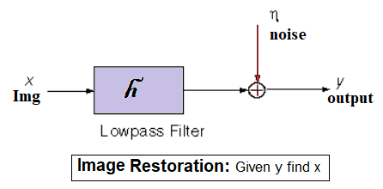

**Figure 1.1**:Schematic diagram for image restoration problem

The aforementioned figure represents the generative model $g(x,y)=f(x,y)⊛h(x,y)+n(x,y)$, where:

* $f\left(x,y\right)$ is the original image (represented by $x$ in the aforementioned figure)
* $h\left(x,y\right)$ is the **point spread function** (**PSF**), a convolution kernel
* $n\left(x,y\right)$ is the noise signal
* $g\left(x,y\right)$ is the convolved output image (represented by $y$ in the figure)

When the noise is not present in the above model, the problem reduces to deblurring; there are several techniques for non-blind and blind deblurring (a few of them we shall implement).

When the blur kernel is absent, the problem reduces to denoising, typically done by spatial / frequency domain filters, let us start with a generalized form of one such non-linear spatial filter.

Inverse problems in image processing

As discussed in the introduction section, the image degradation can be represented by a convolution with a PSF along with adding noise to the image [4], such that it can be modeled as $g=Af_{true}+η$, where $A$ denotes two-dimensional convolution with a Gaussian with standard deviation $σ$ and $η$ denotes additional noise of standard deviation $θ$.

Here $f_{true}$ is the original image (not available to us), all we have is the degraded image $g$ and the convolution matrix $A$ (for non-blind convolution). We want to obtain an estimate ${\hat{f}}_{true}$.

The class of problems is often known as an inverse problem in image processing, where we aim at the data estimation from inadequate or noisy observations, and it is often encountered in practice. It is an ill-posed problem, and the solution is non-unique due to noise and lack of information. Hence, we aim to obtain an approximate solution.

In this section we shall use normal equations (with regularization) to obtain an estimate for the original image.

Let us start by importing all the required libraries using the following code snippet:

%matplotlib inline  
import numpy as np  
import matplotlib.pyplot as plt  
from scipy.ndimage.filters import gaussian_filter  
from skimage.metrics import peak_signal_noise_ratio as psnr  
from scipy.sparse.linalg import LinearOperator, gmres  
import warnings  
warnings.filterwarnings('ignore') # ignore warnings

Let us define the convolution process with Gaussian blur kernel with variance $σ^{2}$, using the gaussian_filter() function from scipy.ndimage.filters module.

Implement the degradation process with the function degrade, which first applies the convolution, followed by addition of a standard normal noise of variance $θ^{2}$, as shown in the following code block.

Let us make $σ$ and $θ$ variables of the process:

def A(f, sigma):  
 return gaussian_filter(f, sigma)  
  
def degrade(f, sigma, theta):  
 g = A(f, sigma)   
 g += theta*np.random.randn(g.shape[0], g.shape[1])  
 return g  
   
sigma, theta = 0.15, 0.075  
im = rgb2gray(imread('images/Img_01_17.jpg'))  
f_true = im  
g = degrade(f_true, sigma, theta)

From the degradation equation, we can see that it can be represented as an optimization (minimization) problem with the classic OLS loss function along with a Ridge ($L_{2}$) penalization term as:

$$\min_{f} {\left(g-Af\right)}^{T}\left(g-Af\right)+αf^{T}f$$

With the solution obtained by the normal equation (prove it):

$$f={\left(A^{T}A+αI\right)}^{-1}A^{T}g$$

Now, let us use deconvolution using the normal equation, i.e., find $f_{α}$ as the solution to $\left(A^{T}A+αI\right)f_{α}=A^{T}g$.

We can solve the above problem using a Krylov solver such as the **generalized minimal residual method** (**GMRES**).

Since the explicit matrix representation of $A$ is infeasibly large, pass the solver instead of a function that computes $\left(A^{T}A+αI\right)f_{α}$:

$$z=A^{T}A\left(f,α\right)$$

Which performs the following two-step process:

$$y=A\left(f\right)$$

$$z=A^{T}\left(y\right)+αf$$

The following code snippet solves the above equation with the function gmres() from scipy.sparse.linalg module and obtains an estimate for $\hat{f}$ for the original image. gmres(A, b) uses GMRES iteration to solve the linear system of equations $Ax=b$:

def ATA(f, alpha=1e-2):  
 y = A(f, sigma)  
 z = A(y, sigma) + alpha*f  
 return z  
h, w = g.shape  
AL = LinearOperator((w*h,w*h), ATA)  
ATg = np.ravel(A(g, sigma))  
f_hat = np.reshape(gmres(AL, ATg)[0], (h,w))

Plot the degraded image and the restored one with the following code block:

plt.figure(figsize=(20,10))  
plt.subplot(121), plt.imshow(g), plt.title('degraded, PSNR: {:.02f}' \  
 .format(psnr(f_true, g)), size=20), plt.axis('off')  
plt.subplot(122), plt.imshow(f_hat), plt.title('restored, PSNR: {:.02f}' \  
 .format(psnr(f_true, f_hat)), size=20), plt.axis('off')  
plt.tight_layout()  
plt.show()

Once you run the aforementioned code snippet, you should obtain the following figure:

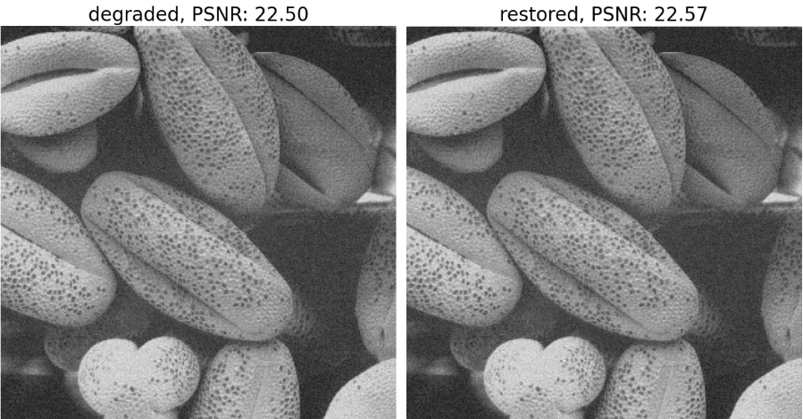

**Figure 1.2**:Image restoration withtheGMRES method

Denoising with weighted median filtering

When an image (a 2D or 3D signal) is transmitted over some distance over a communication channel, it frequently gets contaminated by noise. The simplest model for the acquisition of noise by a signal is additive noise, with the form:

$$\underset{\text{degraded signal}}{g\left(x,y\right)}=\underset{\text{original signal}}{f\left(x,y\right)}+\underset{noisesignal}{η\left(x,y\right)}$$

The basic assumptions for noise signal $η\left(x,y\right)$ are the following:

* Noise is additive.
* Noise is a random signal (with white Gaussian noise having $0$ mean).
* Noise is a high-frequency signal.

Again, our objective of denoising is to remove noise $η\left(x,y\right)$ from the noisy image $g\left(x,y\right)$, while retaining most of the important signal features. Here, we shall use a weighted median filter to achieve the same.

A simple median filter is a nonlinear spatial filter that replaces each pixel with the median from a set in a window (patch) surrounding the pixel. This has the effect of minimizing the absolute prediction error. The output of the filter can be written as follows:



Where $w\left(s\right)$ is a window surrounding pixel $s$. It can be shown that $Y_{s}$ is minimum when $θ=\underset{k∈w\left(s\right)}{median}\left(X_{k}\right)$ (see question $1$ in the exercise and reference [1]).

The median filter is particularly very useful for removing the **salt and pepper** (**s&p**) noise from an image. The weighted median filter generalizes the median filter by allowing some pixels in the window to have more influence on the output than others. Here, the output is written as follows:



Where $α_{s-k}$ are weighting factors which determine the relative influence pixels in $w\left(s\right)$ have on the output. A typical set of weights is shown as follows:

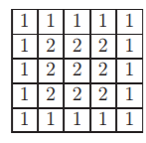

**Figure 1.3**:Sample weights for a weighted median filter

This weight mask allows the pixels closer to the current pixel to have a stronger influence on the output.

In this problem, we shall implement the weighted median filter function and apply it to denoise an IC (integrated circuit) image degraded with s&p noise.

Let us start by importing the required libraries by using the following few lines of code:

importcv2

fromskimage**.**utilimportrandom_noise

Now, let us implement the function weighted_median() that applies the **weighted median filter** (**WMF**) on an image. The function accepts a (noisy) input image and a weight mask for the WMF. Here is how the algorithm goes:

As done for other spatial filters, a kernel window will be slid across the image.

For each position of the window, first, sort the pixels in the window in descending order. Place the corresponding pixel weights in the same order as the sorted pixels.

$$X_{\left(1\right)},X_{\left(2\right)},…,X_{\left(p\right)}$$

$$α_{\left(1\right)},α_{\left(2\right)},…,α_{\left(p\right)}$$

Then determine the weighted median $X_{\left(i_{m}\right)}$ by incrementing the index $i_{m}$ until the following holds true.

$$\sum_{i=1}^{i_{m}}{α_{\left(i\right)}}≥\sum_{i=i_{m}+1}^{p}{α_{\left(i\right)}}$$

The function np.argsort() is used to obtain the sorted indices of the pixels in a window. The function np.cumsum() is used to compute the cumulative sum of the weight mask values in the following implementation.

def weighted_median(im, mask):  
 h, w = im.shape  
 sz = mask.shape[0]  
 im1 = im.copy()  
 mask1 = mask.ravel()  
 for i in range(h-sz+1):  
 for j in range(w-sz+1):  
 win = im[i:i+sz, j:j+sz].ravel()  
 indices = np.argsort(win)[::-1]  
 win, mask1 = win[indices], mask1[indices]  
 csum1, csum2 = np.cumsum(mask1), np.cumsum(mask1[::-1])[::-1]  
 k = 0  
 while csum1[:k].sum() < csum2[k:].sum():  
 k += 1  
 im1[i+sz//2, j+sz//2] = win[k]  
 return im1

Read the input gray-scale image. Add impulse (s&p) noise to the input image using the function random_noise() from skimage.util module to obtain the noisy image. Construct the weight mask aforementioned. Subsequently, the weighted median filter function is applied to denoise (smooth) the noisy image by invoking the weighted_median() function with the noisy image and the weighted mask constructed as follows:

im = cv2.imread('images/Img_01_00.jpg', 0)  
im = im / im.max()  
noisy_im = random_noise(im, mode='s&p')  
weight_mask = np.ones((5,5))  
weight_mask[1:-1,1:-1] = 2  
denoised_im = weighted_median(noisy_im, weight_mask)

Plot the original input image, the noisy (degraded) image, and the denoised (restored) output image side-by-side using the following code snippet. Let us use scikit-image.util module’s peak_signal_noise_ratio() function to compute the **PSNR** (**Peak Signal-to-Noise Ratio**, it measures the quality of a reconstructed image by comparing it to the original and computed using the formula **PSNR $= 10 \log_{10}\left(\frac{MAX² }{MSE}\right)$**  , where **MAX** is the maximum pixel value and **MSE** is the mean squared error.) of the noisy or denoised images and observe that PSNR improved a lot after restoration. You should obtain a figure as follows:

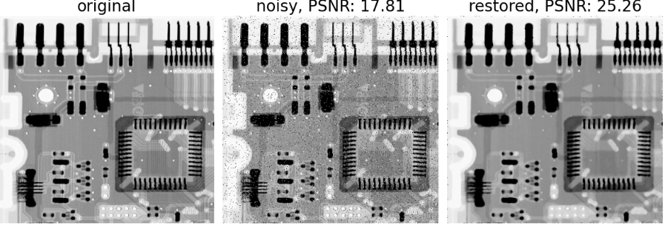

**Figure 1.4**:Image restoration with weighted median filter

Non-blind deconvolution for image restoration

Deconvolution is the operation, which is inverse to convolution, it is a computationally intensive image processing technique for image restoration. In general, the objective of deconvolution is to find an (approximate) solution for $f$ from a convolution equation of the form: $g=f⊛h+ϵ$, given $g$ and the convolution kernel $h$. In this section, we shall discuss a few deconvolution algorithms with the assumption that the deconvolution is non-blind, i.e., the **PSF** (point spread function) or the **kernel $h\left(.\right)$** is known.

Image deconvolution with inverse filter

The inverse filter is the most straightforward deconvolution method. Considering that the convolution of two images in the spatial domain is equivalent to multiplying the Fourier transform of the two images (by the convolution theorem), the inverse filter consists of inverting the multiplication.

If in the spatial domain, the convolution operation is represented as $g\left(x,y\right)=f\left(x,y\right)⊛h\left(x,y\right)$, in the frequency domain it can be represented by a simple multiplication $G\left(u,v\right)=F\left(u,v\right)×H\left(u,v\right)$, where $F$, $H$ and $G$ represent the **DFT** (**Discrete Fourier Transform**, it converts a spatial-domain image into its frequency components, computed as $F(u, v) = \sum_{i=0}^{M-1}{\sum_{j=0}^{N-1}{f(x, y) e^{-2πi\left(\frac{ux}{M} + \frac{vy}{N}\right)}}}$) of $f$ (the original $M×N$ image), $h$ (the convolution kernel) and $g$ (the convolved image), respectively (note that we are ignoring the noise here, the impact of noise on inverse filter is left as an exercise). A naive approach for image restoration is to multiply the DFT of the blurred image by inverse of $H\left(u,v\right)$:

$$\hat{F}\left(u,v\right)=\frac{G\left(u,v\right)}{H\left(u,v\right)}=F\left(u,v\right)×\frac{H\left(u,v\right)}{H\left(u,v\right)}=F\left(u,v\right)$$

The above method is called **inverse filtering**, where $\frac{1}{H\left(u,v\right)}$ is the inverse filter.

However, the problem in this formulation is that $\frac{1}{H\left(u,v\right)}$ may not exist / it may be computationally impossible to compute $\frac{1}{H\left(u,v\right)}$ (e.g., when $H\left(u,v\right)≈0$). The ideal (more stable) inverse filter (also known as **pseudo-inverse filter**) can be approximated as follows:

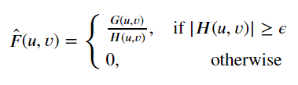

**Figure 1.5**:Pseudo-inverse filter

Where $ϵ$ is a small threshold.

Another way to compensate the values close to zero in $H$ is to just get rid of high frequency components beyond a cutoff-threshold (e.g., $u^{2}+v^{2}>η$) with naive inverse filtering with the deconvolution operator $\frac{1}{H\left(u,v\right)}$ as follows:

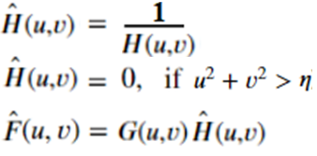

**Figure 1.6**:Another implementation of the inverse filter

Where $η$ is a threshold on a high frequency.

In this problem, we shall implement the pseudo-inverse filter using the above two approaches and restore a degraded image. Let us start by importing the required libraries using the following lines of code:

from scipy import signal  
import scipy.fftpack as fp  
from skimage.io import imread  
from skimage.color import rgb2gray  
from mpl_toolkits.mplot3d import Axes3D  
from matplotlib.ticker import LinearLocator, FormatStrFormatter

Let us implement the frequency domain convolution using the function convolve2d(), notice that before performing the convolution as simple multiplication in the frequency domain, we must ensure that the PSF (convolution kernel) is padded properly to have shape exactly equal to the image shape.

Let us also implement the pseudo-inverse filter and use the post-processing cutoff, described as follows:

def convolve2d(im, psf, k):  
 M, N = im.shape  
 freq = fp.fft2(im)  
 assert(k % 2 == 1 and k > 0 and k <= min(M,N))   
 # assumption: min(M,N) >= k > 0, k odd, kxk kernel  
 psf = np.pad(psf, (((M-k)//2,(M-k)//2+(1-M%2)), ((N-k)//2,(N-k)//2+(1-N%2))), \  
 mode='constant')   
 freq_kernel = fp.fft2(fp.ifftshift(psf))  
 return np.abs(fp.ifft2(freq*freq_kernel))  
  
def inverse_filter_cutoff(y, h, eta):  
 Hf = fp.fft2(fp.ifftshift(h))  
 M, N = Hf.shape  
 u, v = np.meshgrid(range(N), range(M))  
 indices = np.sqrt(u**2 + v**2) <= eta  
 Hf[indices] = np.ones((M,N))[indices] / Hf[indices]  
 Hf[np.sqrt(u**2 + v**2) > eta] = 0  
 Yf = fp.fft2(y)  
 I = Yf*Hf   
 im = np.abs(fp.ifft2(I))  
 return im, Hf  
  
def pseudo_inverse_filter(y, h, epsilon):  
 Hf = fp.fft2(fp.ifftshift(h))  
 M, N = Hf.shape  
 Hf[(np.abs(Hf)<epsilon)] = 0  
 indices = np.where((np.abs(Hf)>=epsilon))  
 Hf[indices] = np.ones((M,N))[indices] / Hf[indices]  
 Yf = fp.fft2(y)  
 I = Yf*Hf   
 im = np.abs(fp.ifft2(I))  
 return im, Hf

Let us implement the following functions to plot in the frequency domain, both in 2D and 3D:

def plot_freq_filter(F, title, size=20):  
 plt.imshow(20*np.log10( 0.01 + np.abs(fp.fftshift(F))), cmap='inferno')  
 plt.title(title, size=size), plt.colorbar(orientation='horizontal')  
  
def plot_freq_spec_3d(freq):  
 fig = plt.figure(figsize=(10,10))  
 ax = fig.gca(projection='3d')  
 Y = np.arange(-freq.shape[0]//2,freq.shape[0]-freq.shape[0]//2)  
 X = np.arange(-freq.shape[1]//2,freq.shape[1]-freq.shape[1]//2)  
 X, Y = np.meshgrid(X, Y)  
 Z = (20*np.log10(0.01 + fp.fftshift(freq))).real  
 surf = ax.plot_surface(X, Y, Z, cmap=plt.cm.inferno, linewidth=0, \  
 antialiased=True)  
 ax.zaxis.set_major_locator(LinearLocator(10))  
 ax.zaxis.set_major_formatter(FormatStrFormatter('%.02f'))  
 plt.show()

Now, let us degrade a couple of grayscale input images with two different types of blur kernels, first with a Gaussian blur and then using a motion blur kernel, separately and restore the degraded versions in each case using the pseudo-inverse filters (using the functions inverse_filter_cutoff() and pseudo_inverse_filter()) compare the quality of the denoised images with PSNR metric and plot the frequency specturms using the following code snippets.

Gaussian blur kernel

Gaussian blur kernel (in image processing) is a kernel (a matrix or a 2D array) used to smooth or blur an image by averaging pixel values with a Gaussian distribution, reducing noise and detail. It applies a weighted average to the surrounding pixels, with the center pixel having the highest weight and decreasing weights for pixels farther from the center, following the shape of a Gaussian (bell curve).

Mathematically, a 2D Gaussian function is defined as:

$$G(x,y)=\frac{1}{{2πσ}^{2}}​e^{-\frac{x2+y2}{{2σ}^{2}}}​$$

Where:

* $x, y$ are the pixel coordinates relative to the center of the kernel
* $σ$ is the standard deviation (controls the extent of blurring)
* $G(x,y)$ gives the weight for each pixel based on its distance from the center

The kernel values are derived from this Gaussian function and normalized so that they sum to 1, ensuring no change in image brightness. The image is convolved with this kernel to produce the blurred effect. The following Python code snippet shows how a degraded image (blurred with Gaussian kernel is restored using an inverse filter):

im = rgb2gray(imread('images/Img_01_13.jpg'))   
(M, N), k, sigma2, nsigma2 = im.shape, 15, 0.125, 0.0025  
kernel = np.outer(signal. windows.gaussian(k, sigma2), \  
 signal. windows.gaussian(k, sigma2))  
im_blur = convolve2d(im, kernel, k) #, mode='same')  
im_cor = random_noise(im_blur, var=nsigma2)  
freq = fp.fft2(im_cor)  
epsilon = 1e-3  
eta = 1 / epsilon  
kernel = np.pad(kernel, (((M-k)//2,(M-k)//2+1), ((N-k)//2,(N-k)//2+1)), \  
 mode='constant')  
im_res_cutoff, F_cutoff = inverse_filter_cutoff(im_cor, kernel, eta)  
im_res_pseudo, F_pseudo = pseudo_inverse_filter(im_cor, kernel, epsilon)

The aforementioned Python code demonstrates image restoration using an inverse filter for a degraded image. The following is a breakdown of how it works:

* **Image loading and conversion**: The image is loaded and converted to grayscale using rgb2gray(imread().
* **Defining image parameters**:
* **M, N**: Dimensions of the image.
* **k**: Size of the blur kernel.
* **sigma2**: Standard deviation for generating the Gaussian kernel (controls blur intensity).
* **nsigma2**: Variance of the noise added to the blurred image.
* **Generating the blur kernel**:

A Gaussian blur kernel is created using signal. windows.gaussian(), which generates a 1D Gaussian, and np.outer() forms a 2D kernel.

* **Blurring the image**: The image is blurred by convolving it with the Gaussian kernel using convolve2d().
* **Adding noise**: Random noise with variance nsigma2 is added to the blurred image using random_noise() to simulate a noisy, degraded image.
* **FFT of the corrupted image**: The corrupted (blurred and noisy) image is transformed into the frequency domain using the **Fast Fourier Transform** (**FFT**) with fp.fft2().
* **Inverse filter application**:
* **Kernel padding**: The kernel is padded to match the image size using np.pad().
* **Inverse filter**: Two variations of the inverse filter are applied:
* **Cutoff inverse filter** **(inverse_filter_cutoff())**: This applies a frequency domain cutoff to limit high-frequency noise using the inverse of the kernel (with a threshold eta).
* **Pseudo-inverse filter** **(pseudo_inverse_filter())**: This uses a regularized pseudo-inverse approach to stabilize the inversion, avoiding divisions by small values using epsilon.

Both filters attempt to undo the blur and noise degradation, restoring the image. If you run the above code snippet and plot the degraded and restored images (along with the magnitude of the frequency spectrums) using the above two implementations, you should obtain a figure as follows:

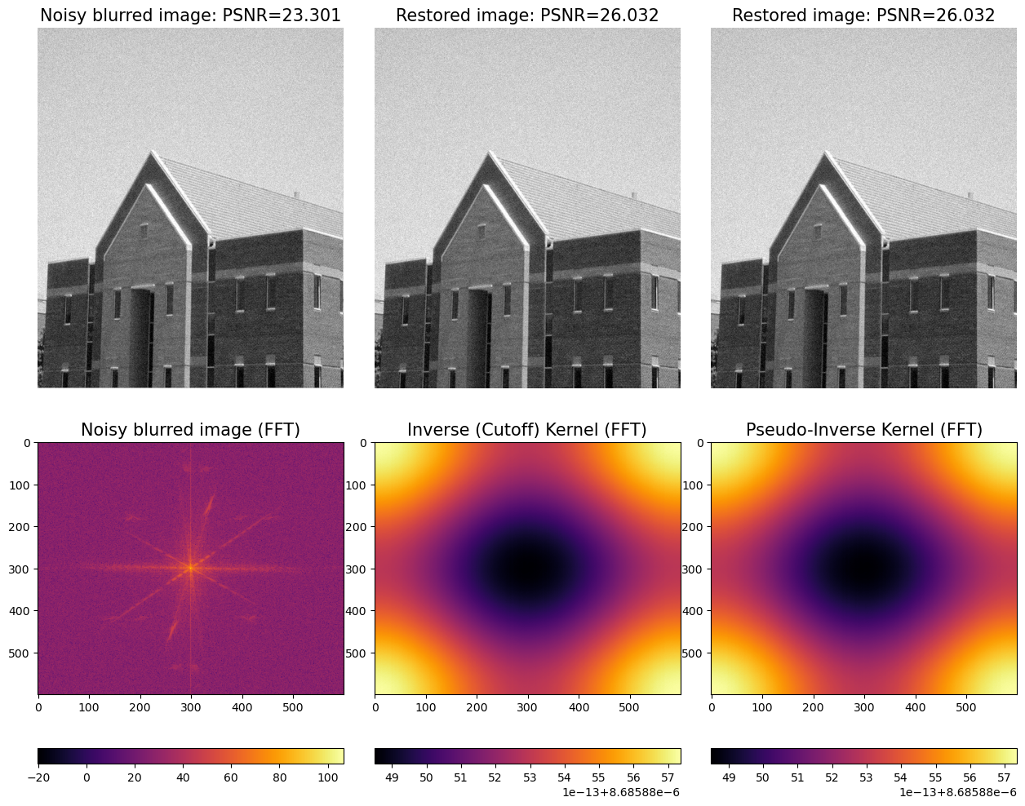

**Figure 1.7**:Image restoration with (pseudo) inverse filter

If you plot the magnitude of frequency spectrums in 3D, you will obtain a figure like the next one:

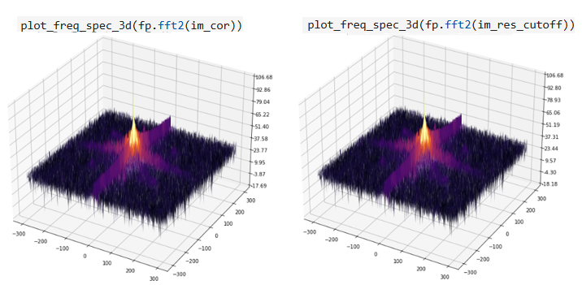

**Figure 1.8**:Frequency spectrum of the degraded vs. restored image

As we have seen in the last section, Gaussian blur kernel applies a symmetric, isotropic smoothing effect to an image by convolving it with a Gaussian function, which assigns higher weights to pixels closer to the center. It is commonly used to reduce noise or create a soft-focus effect. In contrast, a motion blur kernel simulates the effect of object motion or camera shake by averaging pixel intensities along a specific direction and distance. Unlike Gaussian blur, motion blur is directional and anisotropic, resulting in elongated streaks that mimic the perceived motion. The two serve distinct purposes: Gaussian blur focuses on uniform smoothing, while motion blur captures the directional nature of movement.

Motion blur kernel

A motion blur kernel in image processing is used to simulate the effect of camera or object movement during exposure, causing the image to appear smeared along the direction of motion. It is a linear filter that averages pixel values along a straight line in the direction of the blur, giving the appearance of motion.

Mathematically, a motion blur kernel is often represented as a 2D matrix where non-zero values form a line with equal weights in the direction of the blur. For example, a simple horizontal motion blur kernel of size *N×N* can be written as the following matrix (with the first row as all ones and all the elements of the rest of the matrix as zeros):

$$K=\frac{1}{N}\left[\begin{matrix}1 & ⋯ & 1 \\ ⋮ & ⋱ & ⋮ \\ 0 & ⋯ & 0\end{matrix}\right]$$

In this example, the kernel has *N* non-zero elements (all equal to *1/N*) in the first row, simulating uniform averaging along a horizontal path of length *N*. The image is convolved with this kernel, which results in a blurring effect along the specified motion direction.

For vertical or diagonal motion blur, the non-zero values in the kernel would be arranged along a vertical or diagonal line, respectively. The general motion blur can be extended to other directions by adjusting the orientation of the kernel.

Let us now degrade an image using motion blur and restore (deblur) using the inverse filter, using the following code snippet**:**

im = rgb2gray(imread('images/Img_01_05.jpg'))   
(M, N), k = im.shape, 21 # k x k kernel  
kernel = np.zeros((k, k)) # construct a 21 x 21 motion-blur kernel  
kernel[int((k-1)/2), :] = np.ones(k) # fill the middle row of kernel matrix with 1s  
kernel = kernel / k  
  
im_blur = convolve2d(im, kernel, k)  
im_cor = im_blur  
freq = fp.fft2(im_cor)  
kernel = np.pad(kernel, (((M-k)//2,(M-k)//2+1), ((N-k)//2,(N-k)//2+1)), \  
 mode='constant')  
epsilon = 10e-3  
im_res_pseudo, F_pseudo = pseudo_inverse_filter(im_cor, kernel, epsilon)

A couple of steps from the aforementioned code snippet demand more explanation:

* **Creating the Motion Blur Kernel**:
* A *k x k* matrix of zeros (kernel = np.zeros((k, k))) is created.
* The middle row of this matrix is filled with ones (kernel[int((k-1)/2), :] = np.ones(k)) to simulate horizontal motion blur.
* The kernel is normalized by dividing by *k* to ensure that the sum of all elements is 1, ensuring proper blurring.
* **Blurring the image**:
* The image is blurred by convolving it with the motion blur kernel using convolve2d(). This simulates the motion blur effect on the image.
* In this case, no additional noise is added; the corrupted image im_cor is simply the blurred image.

If you run the aforementioned code snippet and plot the motion-blurred and the deblurred (restored) images in both the spatial and frequency domains, you should obtain a figure as follows:

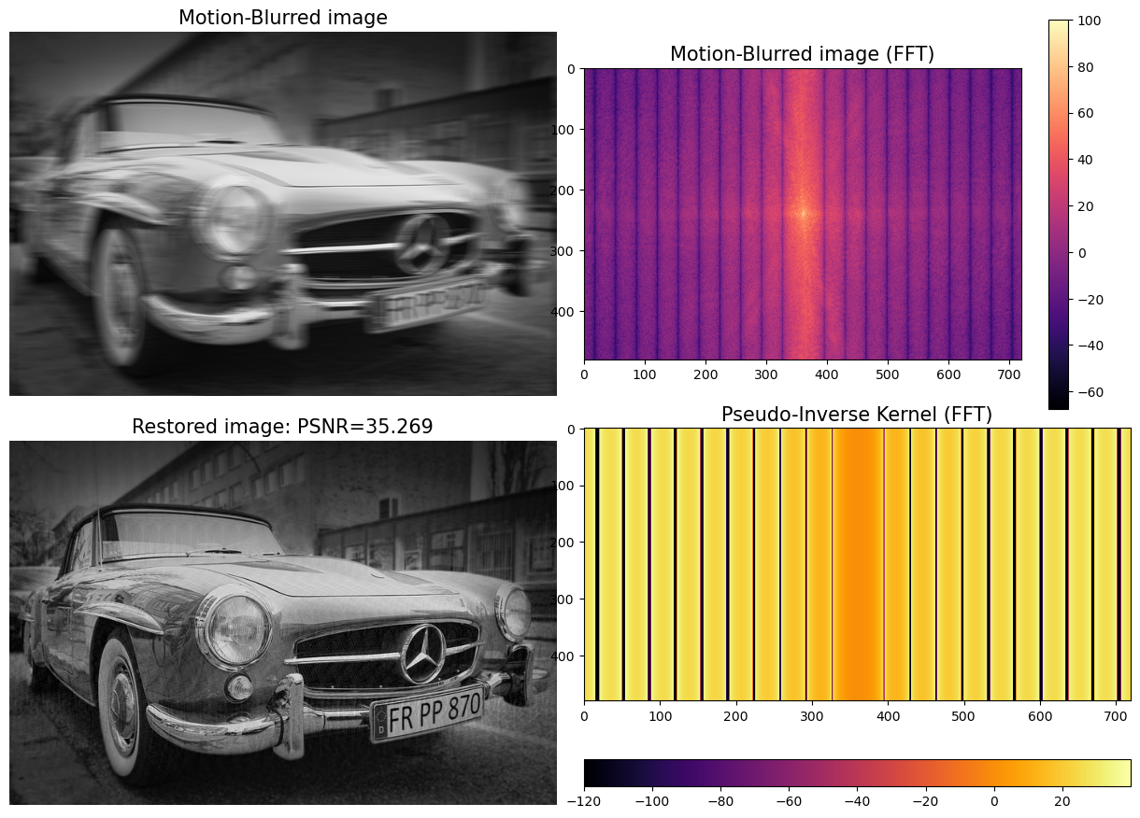

**Figure 1.9**:Restoration of a motion-blurred image with pseudo-inverse filter

If you plot the magnitude of frequency spectrums in 3D, you will obtain a figure as follows:

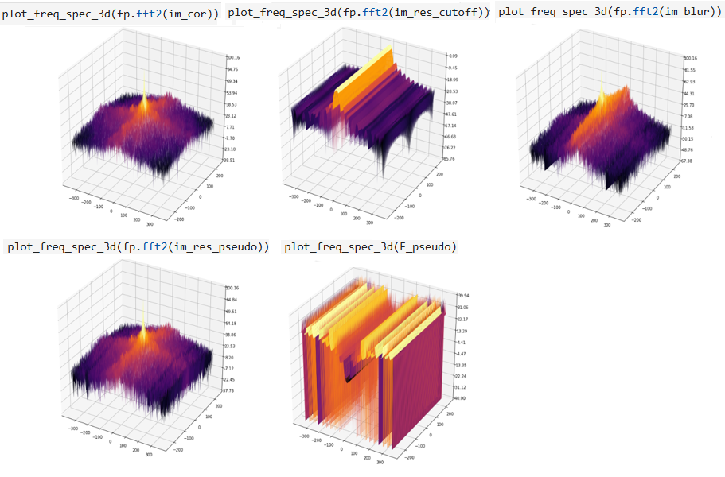

**Figure 1.10**:Frequency spectrum of the image, blur kernel, blurred and restored image

Simulating the bokeh blur

The bokeh effect is a pleasing visual artifact, and it often enhances the aesthetics of a photograph. Let us understand how the effect can be created. Light rays (from light sources) get reflected by the objects in the scene, and the camera lens focuses them onto the image plane. The points that appear in focus are the ones that fall inside a certain distance range, and the remaining ones appear out of focus (being too far / too close). Among these points, the bright spots (e.g., light sources) create circles of confusion that are more visible than the ones created by darker points (by the contrast effect). This phenomenon is known as the bokeh effect. In this problem, you will learn how to *simulate* this effect using Python code with 2D convolution.

Let us start by importing the required libraries using the following code snippet:

from skimage.color import rgb2gray, rgba2rgb

Consider a white pixel at the center of a black image. Let us shift this image in all directions by a single pixel and accumulate the results. It will smear the white pixel over its neighbors.

Let us implement the function apply_bokeh_blur() to simulate this effect. The function takes two arguments: an input image and a binary mask image (a small white star/hexagon/circle at the bottom left corner in a black background) of the same shape. Start with a blank output image where the smearing effects will get accumulated.

For each white pixel $P\left(i,j\right)$ from the mask image, shift the input color image by $\left(i,j\right)$, using the function np.roll() (strengthen the effect by using func(), e.g., a cubic function), multiply it by the mask pixel value, and add the result to the output image.

Finally, normalize the pixel values, as shown in the following code snippet.

You just applied a convolution.

def func(x):  
 return x**3  
def apply_bokeh_blur(img, mask):  
 h, w = mask.shape  
 out = np.zeros(img.shape)  
 total = 0  
 for i in range(h):   
 for j in range(w):   
 if mask[i, j] != 0:   
 out += mask[i, j] * func(np.roll(img, (i,j), (0,1)))  
 total += mask[i, j]  
 out /= total  
 out /= out.max()  
 return out

Read the input color image of an X-mas tree. Let us use a black image with a small white star (mask) at the bottom left corner as the mask image. Invoke the function apply_bokeh_blur() with the input and the mask image to obtain the output image with the desired effect.

mask = rgb2gray(rgba2rgb(imread('images/Img_01_12.png')))  
img = cv2.resize(imread('images/Img_01_13.png') / 255, mask.shape[::-1])  
out = apply_bokeh_blur(img, mask)

Plot the input image and the output image using bokeh blur. Create visually interesting results by varying the shape of the mask (e.g., use a hexagonal mask instead); you should get a figure as follows:

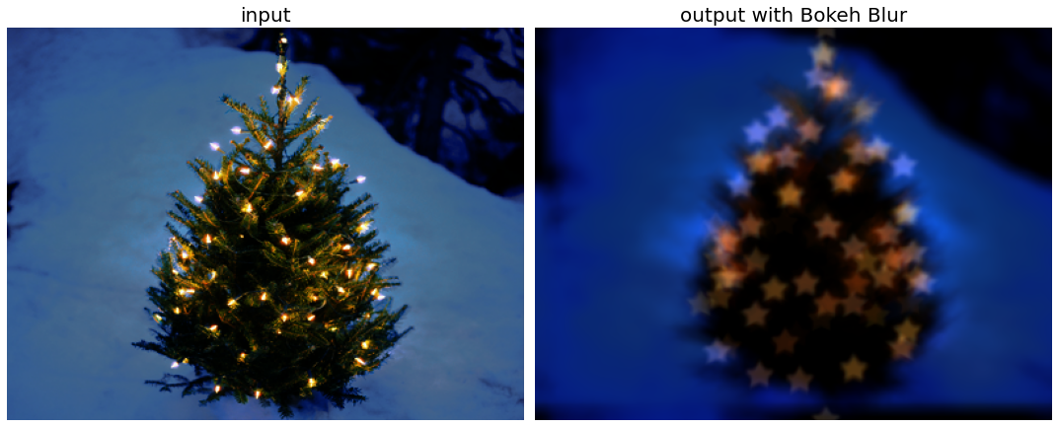

**Figure 1.11**: Applying the bokeh blur to an image

Wiener deconvolution with opencv-python

The inverse filter performs poorly when the noise level is high. Wiener filter is an improved version of the inverse filter, it works in the frequency domain and uses prior regularization (penalization of high-frequency terms which have a poor signal-to-noise ratio). The regularization parameter generally needs to be hand-tuned.

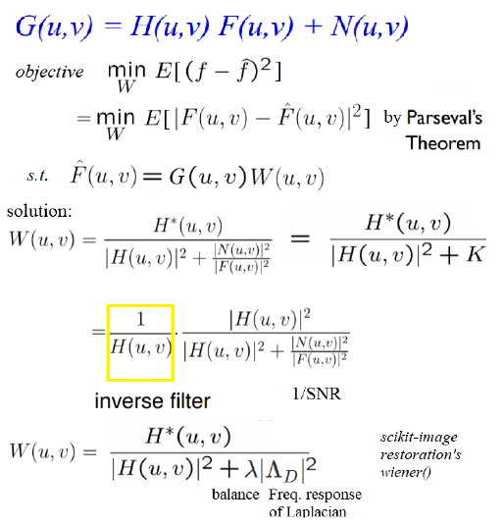

**Figure 1.12**:Wiener deconvolution

The aforementioned figure can be expressed as:

$$W\left(u,v\right)=\frac{1}{H\left(u,v\right)}\frac{1}{1+1/\left({\left|H\left(u,v\right)\right|}^{2}SNR\right)}$$

Where SNR (**signal to noise ratio**) is the ratio of the frequency responses of the original image (signal) to noise.

* First note that $\lim_{N\left(u,v\right)→∞}SNR=0$ and $\lim_{N\left(u,v\right)→0}SNR=∞$, for some frequency $\left(u,v\right)$.
* When the noise is $0$ (i.e. $SNR$  is $∞$), the Wiener filter simply reduces to an *inverse filter*, i.e., $\lim_{N\left(u,v\right)→0}W\left(u,v\right)=\frac{1}{H\left(u,v\right)}.\frac{1}{1+0}=\frac{1}{H\left(u,v\right)}$.
* With the increase of noise at certain frequencies, which results in a drop in the SNR ratio, the Wiener filter attenuates frequencies according to their filtered SNR ratio, since $\lim_{N\left(u,v\right)→∞}W\left(u,v\right)=\frac{1}{H\left(u,v\right)}.\frac{1}{∞}=0$.
* The $λ$ parameter balances between the data and the regularization term.

In this problem, we shall implement the Wiener filter again to deblur a degraded image, but this time using opencv-python (cv2) library functions. It shows how DFT can be used to perform Wiener deconvolution of an image with a user-defined PSF.

Let us first implement the function blur_edge() to apply Gaussian blur on an image. Also, implement the functions motion_kernel() and defocus_kernel() to create the motion blur and defocus blur kernels. The function deconvolve() implements the Wiener deconvolution as follows:

def blur_edge(img, d=31):  
 h, w = img.shape[:2]  
 img_pad = cv2.copyMakeBorder(img, d, d, d, d, cv2.BORDER_WRAP)  
 img_blur = cv2.GaussianBlur(img_pad, (2*d+1, 2*d+1), -1)[d:-d,d:-d]  
 y, x = np.indices((h, w))  
 dist = np.dstack([x, w-x-1, y, h-y-1]).min(-1)  
 w = np.minimum(np.float32(dist)/d, 1.0)  
 return img*w + img_blur*(1-w)  
  
def motion_kernel(angle, d, sz=63):  
 kern = np.ones((1, d), np.float32)  
 c, s = np.cos(angle), np.sin(angle)  
 A = np.float32([[c, -s, 0], [s, c, 0]])  
 sz2 = sz // 2  
 A[:,2] = (sz2, sz2) - np.dot(A[:,:2], ((d-1)*0.5, 0))  
 kern = cv2.warpAffine(kern, A, (sz, sz), flags=cv2.INTER_CUBIC)  
 return kern  
  
def defocus_kernel(d, sz=63):  
 kern = np.zeros((sz, sz), np.uint8)  
 cv2.circle(kern, (sz, sz), d, 255, -1, cv2.LINE_AA, shift=1)  
 kern = np.float32(kern) / 255  
 return kern  
  
def deconvolve(img, kern):  
 kern /= kern.sum()  
 kern_pad = np.zeros_like(img)  
 kh, kw = kern.shape  
 kern_pad[:kh, :kw] = kern  
 freq = cv2.dft(img, flags=cv2.DFT_COMPLEX_OUTPUT)  
 kern_freq = cv2.dft(kern_pad, flags=cv2.DFT_COMPLEX_OUTPUT, nonzeroRows = kh)  
 kern_freq2 = (kern_freq**2).sum(-1)  
 kern_wiener = kern_freq / (kern_freq2 + noise)[...,np.newaxis]  
 res = cv2.mulSpectrums(freq, kern_wiener, 0)  
 res = cv2.idft(res, flags=cv2.DFT_SCALE | cv2.DFT_REAL_OUTPUT)  
 res = np.roll(res, -kh//2, 0)  
 res = np.roll(res, -kw//2, 1)  
 return res

Read the input image as a gray-scale image and apply the Gaussian blur to the image.

img = cv2.imread('images/Img_01_03.jpg', cv2.IMREAD_GRAYSCALE)  
img = np.float32(img) / 255  
img = blur_edge(img)  
angle, d, snr = np.deg2rad(135), 22, 25  
noise = 10**(-0.1*snr)

Defocus the image by applying the defocus kernel and then restore the defocused image using the deconvolve() function defined as follows:

kern_defocus = defocus_kernel(d)  
img_defocussed = cv2.filter2D(img,-1, kern_defocus) # apply defocus blur  
res_defocussed = deconvolve(img_defocussed, kern_defocus)

Next, apply motion blur on the original image and then restore the defocused image using the deconvolve() function defined as follows:

kern_blur = motion_kernel(angle, d)  
img_blur = cv2.filter2D(img,-1, kern_blur) # apply motion blur  
res_blur = deconvolve(img_blur, kern_blur)

Plot the original image, and the defocus / motion-blur kernels. You should obtain a figure as follows:

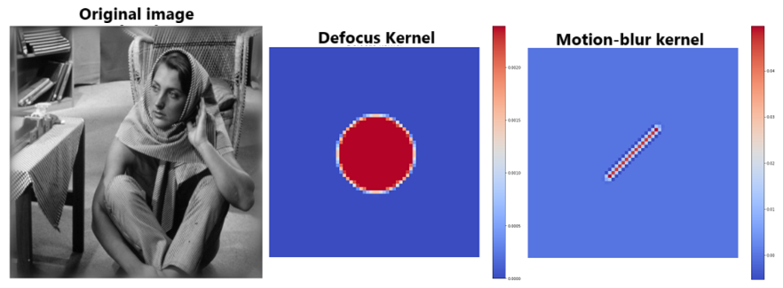

**Figure 1.12**:Input (barbara) image with the defocus and motion blur kernel

Now, if you plot the defocused/blurred/restored images, you should obtain a figure as follows:

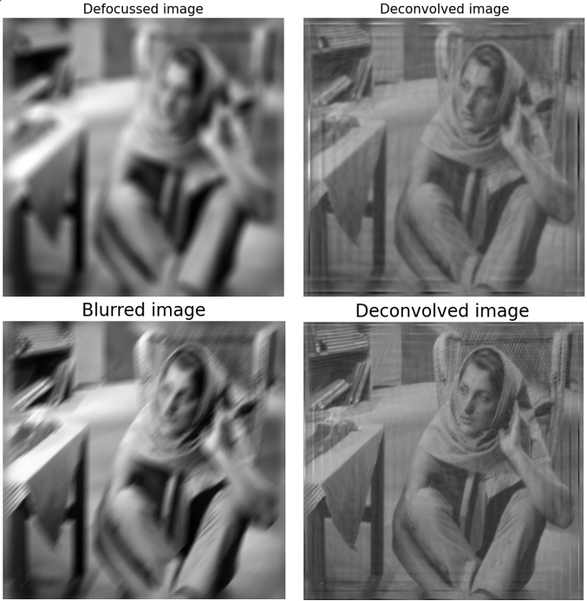

**Figure 1.13**: Restoring defocused/motion/blurred images using deconvolution with the Wiener filter

Deconvolution with (unsupervised) weiner filter with scikit-image

The unsupervised Wiener algorithm uses a data learning algorithm (based on an iterative stochastic Gibbs sampler) to obtain self-tuned regularization parameters $\left[19\right]$. The algorithm is fast since it is based on linear models but may not restore sharp edges like the non-linear methods (e.g., TV restoration).

From the Bayesian perspective, the deconvolved (estimated) image can be defined as the posterior mean (defined by the sum of all possible images weighted by their probability). But the exact sum being intractable, the algorithm uses **Markov Chain Monte Carlo** (**MCMC**) simulation to draw images under posterior law (drawing highly probable images more often than the less probable images) and then computes the empirical mean of the samples.

In this problem, we shall use skimage.resoration module’s implementation of unsupervised Wiener filter to deconvolve/restore an image degraded with noise (we shall also scipy.signal’s implementation of the Wiener filter, we shall leave the comparison of the restored image qualities and parameter tuning for the Gibbs sampler for unsupervised Wiener as an exercise).

Let us start by importing all the required libraries as follows:

from skimage import color, restoration  
from scipy.signal import convolve2d as conv2

Read the cameraman grayscale image and degrade with box-blur and Gaussian noise, as before.

im = rgb2gray(imread('images/Img_01_01.jpg'))  
noisy = im.copy()  
psf = np.ones((5, 5)) / 25  
noisy = conv2(noisy, psf, 'same')  
noisy += 0.1 * im.std() * np.random.standard_normal(im.shape)

Use the unsupervised_wiener() function from skimage.restoration to apply the unsupervised Wiener deconvolution on the degraded image. The function accepts the following arguments:

* image: The degraded input image.
* psf: The impulse function, $5×5$ average kernel is used here.
* reg: The regularization operator, the default of which is Laplacian.

The function returns the deconvolved image (posteriror mean) and a dictionary with the keys noise and prior.

Use scipy.signal module’s wiener() function to deconvolve the degraded image and compare the output with the previous one.

deconvolved_unsup, _ = restoration.unsupervised_wiener(noisy, psf)  
deconvolved = scipy.signal.wiener(noisy, (5,5))

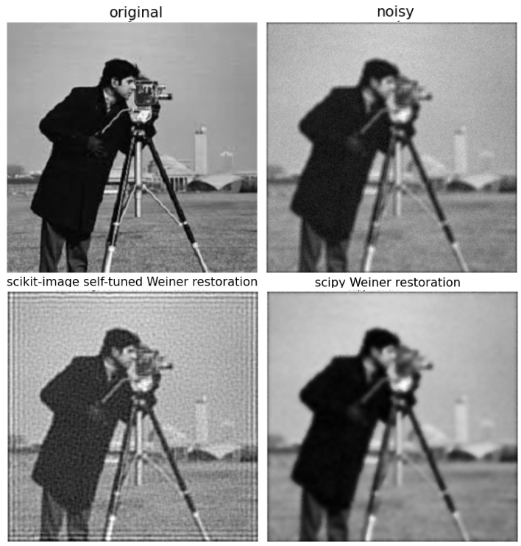

**Figure 1.14**:Image restoration with scipy.signal implementation of Wiener filter and its unsupervised version

Non-blind deconvolution with Richardson-Lucy algorithm

The Richardson–Lucy algorithm, also known as **Lucy–Richardson deconvolution** [9], is an iterative procedure for recovering an underlying image that has been blurred by a known point spread function. It is an iterative Bayesian algorithm for image restoration. The iterative updation step of the algorithm is shown in the following figure:

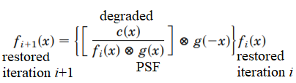

**Figure 1.15**:Iterative updation step of the Richardson-Lucy algorithm

Here, since the PSF $g\left(x\right)$ is known, we can find the restored $f\left(x\right)$ by iterating over the above equation until convergence. An initial guess is required for the restored $f_{0}\left(x\right)$ to start the algorithm. Then, in subsequent iterations, because of the form of the algorithm, large deviations in the guess from the true object are lost rapidly in initial iterations, whereas detail is added more slowly in subsequent iterations. Advantages of this algorithm include a nonnegativity constraint if the initial guess $f_{0}\left(x\right)≥0$. Also, energy is conserved as the iteration proceeds.

In this example, we shall deconvolve an image using Richardson-Lucy deconvolution algorithm, using skimage.restoration module’s implementation. The algorithm is based on a PSF*,* which is described as the impulse response of the optical system. The blurred image is sharpened through a number of iterations, which need to be hand-tuned.

Read the input cameraman image, convert it to grayscale. Use a $5×5$ box kernel to convolve/blur the image and add random Poisson noise to the image of rate $λ$, using the function np.random.poisson(), as shown in the following code snippet:

im = color.rgb2gray(imread('images/Img_01_01.jpg'))  
im_noisy = im.copy()  
psf = np.ones((5, 5)) / 25  
im_noisy = conv2(im_noisy, psf, 'same')  
im_noisy += (np.random.poisson(lam=25, size=im.shape) - 10) / 255.

Now, restore the image using the function richardson_lucy() from scikit-image’s restoration module to run the Richardson-Lucy algorithm, try different number of iterations (e.g., $20$, $50$ etc.).

The function accepts the following arguments, and the relevant ones are described as follows:

* image: The degraded input image.
* psf: The point spread function.
* iterations: Specifies the number of iterations to perform the updates. This works as a regularization hyperparameter.

The function returns the deconvolved (restored) image.

deconvolved_RL = restoration.richardson_lucy(im_noisy, psf, num_iter=20)

Plot the restored images for different iterations, along with the input and noisy image. You should get a figure as follows:

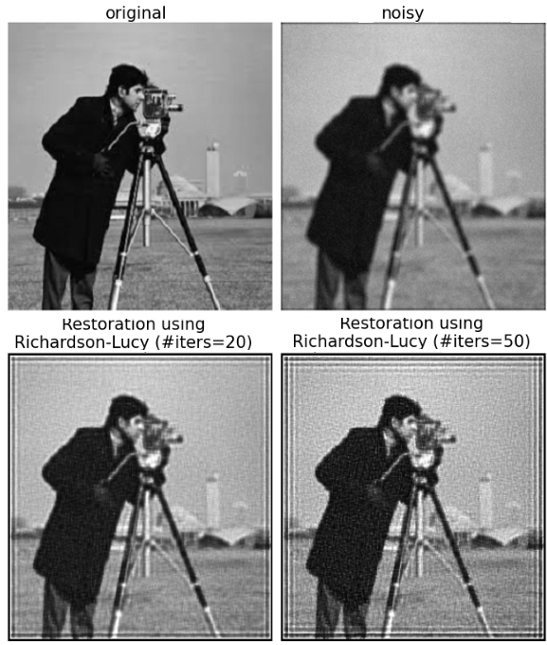

**Figure 1.16**:Restoring degraded cameraman image with (non-blind) Richardson-Lucy algorithm

Blind deconvolution with Richardson-Lucy algorithm

So far, we have seen image restoration with non-blind deconvolution methods. When the PSF is known, the problem of deblurring can be considered as inverse filtration of the observed image.

When the PSF is unknown, we need to have approaches to simultaneous iterative deconvolution and PSF estimation. The **Lucy-Richardson** (**LR**) **maximum likelihood** (**ML**) method of deconvolution was supplemented by an iterative schema of PSF estimation in an extended manner [10], as shown in the following figure:

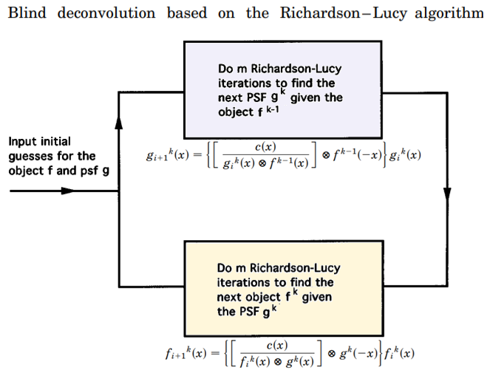

**Figure 1.17**: Image restoration with blind deconvolution using the Richardson-Lucy algorithm

In the blind form of this algorithm two of these deconvolution steps are required, as shown in the aforementioned figure. At the $k^{th}$ blind iteration, it is assumed that the object is known from the ${\left(k-1\right)}^{th}$ iteration. The PSF $g^{k}\left(x\right)$ is then calculated for a specified number of Richardson–Lucy iterations, as in equation $\left(1\right)$ following, where the index $i$ represents the Richardson–Lucy iteration:

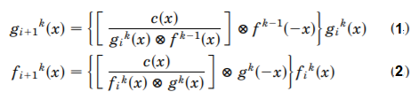

**Figure 1.18**:Iterative updation of the kernel and the deconvolved image with blind Richardson-Lucy

This equation is essentially an inverse of equation $\left(2\right)$, since the object and the PSF have reverse roles, and it calculates the PSF from the object. Then $f^{k}\left(x\right)$ is calculated for the same number of Richardson–Lucy iterations. This is done with the PSF evaluated from the full iteration of equation in the non-blind case, as discussed earlier. In this case, the iteration is performed in the normal manner of the equation corresponding to the non-blind case, as shown in equation $\left(2\right)$ aforementioned.

The degraded image is again given as $c\left(x\right)$ in both the equations $\left(1\right)$ and $\left(2\right)$. The loop is repeated as required. Initial guesses are made for the object $f_{0}^{0}\left(x\right)$ and the PSF $g_{0}^{0}\left(x\right)$, and an algorithm loop of the form shown in the aforementioned figure is reperformed. In this problem, we shall implement the blind version of the Richardson-Lucy algorithm.

Let us start by importing the required libraries:

from scipy.signal import convolve2d, fftconvolve  
from skimage import img_as_float

Let us implement the following function richardson_lucy_blind() using the aforementioned algorithm:

def norm(im):  
 return im - im.min() / (im.max() - im.min())  
  
def richardson_lucy_blind(image, psf, original, num_iter=5):   
 im_deconv = np.full(image.shape, 0.1, dtype='float') #image.copy()   
 for i in range(num_iter):  
 psf_mirror = np.flip(psf)  
 conv = fftconvolve(im_deconv, psf, mode='same')  
 relative_blur = image / (conv + 0.001)  
 im_deconv *= fftconvolve(relative_blur, psf_mirror, mode='same')  
 im_deconv_mirror = np.flip(im_deconv)  
 psf *= fftconvolve(relative_blur, im_deconv_mirror, mode='same')  
 # plot original and restored images along with the estimated blur PSF here  
 # your code here  
 return norm(im_deconv), psf

Read the *Lena* grayscale image as input. Apply $7×7$ box-blur kernel to blur the image and add Gaussian noise to degrade the image. Initialize the (unknown) PSF randomly to start with as follows:

img = img_as_float(imread('images/Img_01_09.jpg', True))  
original, k = img.copy(), 7  
M, N = img.shape   
psf = np.ones((k, k)) / k**2  
img = convolve2d(img, psf, 'same')  
img += 0.3 * img.std() * np.random.default_rng().standard_normal(img.shape)

Invoke the function richardson_lucy_blind() on the degraded image for simultaneous estimation of the blur kernel (starting from an initial random one) and restoration of the image, as shown:

psf = np.random.random((k, k))  
psf /= np.sum(psf)   
psf = np.pad(psf, (((M-k)//2,(M-k)//2+(1-M%2)), ((N-k)//2,(N-k)//2+(1-N%2))), \  
 mode='constant')   
deconvolved = richardson_lucy_blind(img, psf, original, 3)

Plot the restored image (compute the PSNR) along with the estimated PSF for the first couple of iterations, and you should obtain a figure like the one shown as follows:

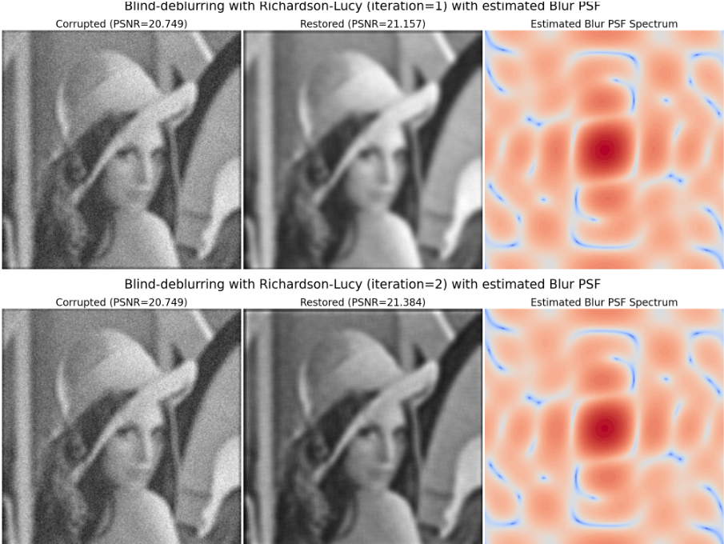

**Figure 1.19**:Restoring degraded Lena image with (non-blind) Richardson-Lucy algorithm

Total variation denoising

TV denoising methods assume that the high total variation in signals is caused by excessive/spurious detail. The goal is to remove unwanted but preserve important details (e.g., edges) in the image by reducing the total variation of the (degraded) image so that it remains a close match to the original image. This is known as the **Rudin-Osher-Fatemi** (**ROF**) model [5]. The original TV regularization method targeted image denoising under Gaussian noise, nevertheless it has evolved into a more general technique for inverse problems.

In this section we shall use functions from skimage.restoration to implement TV denoising.

TV denoising with Rudin-Osher-Fatemi algorithm

TV regularization is a technique that was originally developed for **additive white Gaussian noise** (**AWGN**) image denoising by *Rudin*, *Osher*, and *Fatemi*. They proposed to estimate the denoised image u as the solution of a minimization problem:

$${min \atop u∈BV(Ω)}{\left\|u\right\|}_{TV(Ω)}+\frac{λ}{2}\int_{Ω}{{(f(x)-u(x))}^{2}dx}$$

Where $λ$ is a positive parameter, here the first term is for regulariation and the second term represents the data fidelity term, which depends on the noise model. This $l_{2}$- $TV$ the problem is referred to as the ROF problem.

Denoising is performed as an infinite-dimensional minimization problem, where the search space is all **bounded variation** (**BV**) images. $BV\left(Ω\right)$ refers the family of functions (with bounded variation) over the domain $Ω$, $TV\left(Ω\right)$ is the total variation over the domain, and $λ$ is a penalty term. When $u$ is *s*mooth, and the total variation is equivalent to the integral of the gradient magnitude:

$${\left\|u\right\|}_{TV\left(Ω\right)}=\int_{Ω}{\left\|∇u\right\|dx}$$

$∥⋅∥$ is the Euclidean norm. Then, the objective function of the minimization problem becomes:

$${min \atop u∈BV(Ω)}\int_{Ω}{\left[\left\|∇u\right\|+\frac{λ}{2}{(f-u)}^{2}\right]dx}$$

Using the Euler-Lagrange equation for minimization of the above functional [6] results in the following **partial differential equation** (**PDE**):

$$\left\{\begin{aligned}∇.\left(\frac{∇u}{\left\|∇u\right\|}\right)+λ\left(f-u\right)=0, u∈Ω \\ \frac{∂u}{∂n}=0, u∈∂Ω\end{aligned}\right.$$

Here is the time-dependent version of the ROF equation:

$$\frac{∂u}{∂t}=∇.\left(\frac{∇u}{\left\|∇u\right\|}\right)+λ\left(f-u\right)$$

In this section, you will learn how to denoise an image with scikit-image implementation of TV denoising, using the algorithm proposed by *Chambolle*, as shown in the following figure:

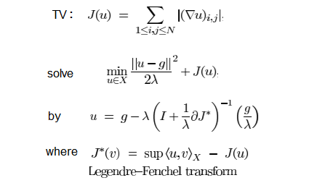

**Figure 1.20**:TV denoising algorithm by Chambolle

Total variation denoising tries to minimize the total variation of an image (which is roughly equivalent to the integral of the norm of image gradient) and often produces cartoon-like (piecewise-constant) images.

Let us start by importing the required libraries, using the following code snippet. Notice that the version of the scikit-image library must be $≥0.14$.

import skimage  
print(skimage.__version__) # should be >= 0.14  
from skimage.restoration import denoise_tv_chambolle

# 0.17.2

Read the image, convert it to a grayscale, and add Gaussian noise to the image using the function np.random.normal().

im = 255*rgb2gray(imread('images/Img_01_01.jpg'))  
noisy = im + np.random.normal(loc=0, scale=im.std() / 4, size=im.shape)

We shall use the function denoise_tv_chambolle() from scikit-image restoration module to implement TV denoining.

The function accepts the following arguments:

* image: Input image to be denoised.
* weight: Denoising weight. Larger weight results in more denoising (at the cost of fidelity to the input image).
* n_iter_max: Maximum number of iteration steps to be run to optimize.

It returns the denoised image.

The following code snippet shows how the function can be used to denoise the cameraman grayscale image:

for weight in [10, 25, 50, 100]:  
 tv_denoised = denoise_tv_chambolle(noisy, weight=weight)

The following figure shows the original, noisy, and TV-denoised images with a couple of different weights:

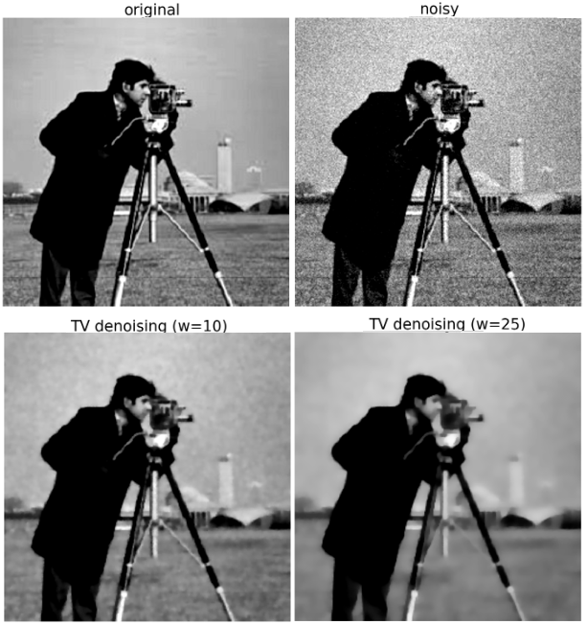

**Figure 1.21**:TV denoising of the noisy cameraman image (with scikit-image’s Chambolle implementation)

As shown in the aforementioned figure, as we go on increasing the weights, we get more denoising effect, at the cost of fidelity to the input image (e.g., texture flattening).

TV denoising with Chambolle vs. Bregman

In this problem, we shall implement total-variation denoising with split Bregman optimization [5], using skimage.restore module functions. As discussed above, TV denoising (also known as TV regularization) aims at finding an image by minimizing the total variation under the constraint of being similar to the input image (controlled using regularization parameter). The coupling between $l_{1}$ and $l_{2}$ terms makes the TV regularization problems hard to solve. This is solved by a split in the $l_{1}$ and $l_{2}$ components of this energy. Starting with an $l_{1}$-constrained problem, the split Bregman formulation is formed, and the optimization problem is solved in an iterative fashion.

Let us start by importing the required libraries using the following code snippet:

from skimage.restoration import denoise_tv_chambolle, denoise_tv_bregman

Read the image, convert it to grayscale, and add Gaussian noise to the image, this time using the random_noise() function from skimage.util.

img = img_as_float(imread('images/Img_01_30.png'))  
noisy = random_noise(img, var=0.02)  
noisy = np.clip(noisy, 0, 1)

We shall use the function denoise_tv_bregman() from scikit-image restore module.

The function accepts the following arguments:

* image: noisy input image (converted to float with pixel values in $\left[0,1\right]$ using img_as_float).
* weight: denoising weight, the regularization parameter lambda is chosen as *2 * weight*.
* isotropic: False if anisotropic TV denoising.
* Channel_axis: For color images, specify the color channel (e.g., the last channel, i.e., -1), total-variation denoising is applied separately for each channel.

The function returns a denoised image.

The next code snippet shows how the function can be used to denoise the following color image for different weights and isotropic/anisotropic mode, compares it with denoising using TV Chambolle, and terms of PSNR values of the restored images (with the function peak_signal_noise_ratio() from skimage.metrics).

def plot_image(img, title):  
 plt.imshow(img), plt.axis('off'), plt.title(title, size=20)  
   
plt.figure(figsize=(20,22))  
plt.subplot(331), plot_image(img, 'Original')  
plt.subplot(332), plot_image(noisy, 'Noisy, PSNR: {}' \  
 .format(np.round(psnr(img, noisy),3)))  
i = 3  
for weight in [0.1, 0.25]:  
 tvd_out = denoise_tv_chambolle(noisy, weight=weight, channel_axis=-1)  
 plt.subplot(3,3,i)  
 plot_image(tvd_out, 'TVD Chambolle (w={}), PSNR: {}' \  
 .format(weight, np.round(psnr(img, tvd_out),3)))  
 i += 1  
  
for weight in [10, 7]:  
 for isotropic in [False, True]:  
 tvd_out = denoise_tv_bregman(noisy, weight=weight, isotropic=isotropic, \  
 channel_axis=-1)  
 plt.subplot(3,3,i)  
 plot_image(tvd_out, 'TVD Bregman (w={}), PSNR: {}, iso: {}'.format(weight, \  
 np.round(psnr(img, tvd_out),3), str(isotropic)[0]))  
 i += 1  
  
plt.subplots_adjust(wspace=0.05, hspace=0.05, top=0.95, bottom=0, left=0, right=1)  
plt.show()

If you run the aforementioned code snippet, you should obtain a figure as follows:

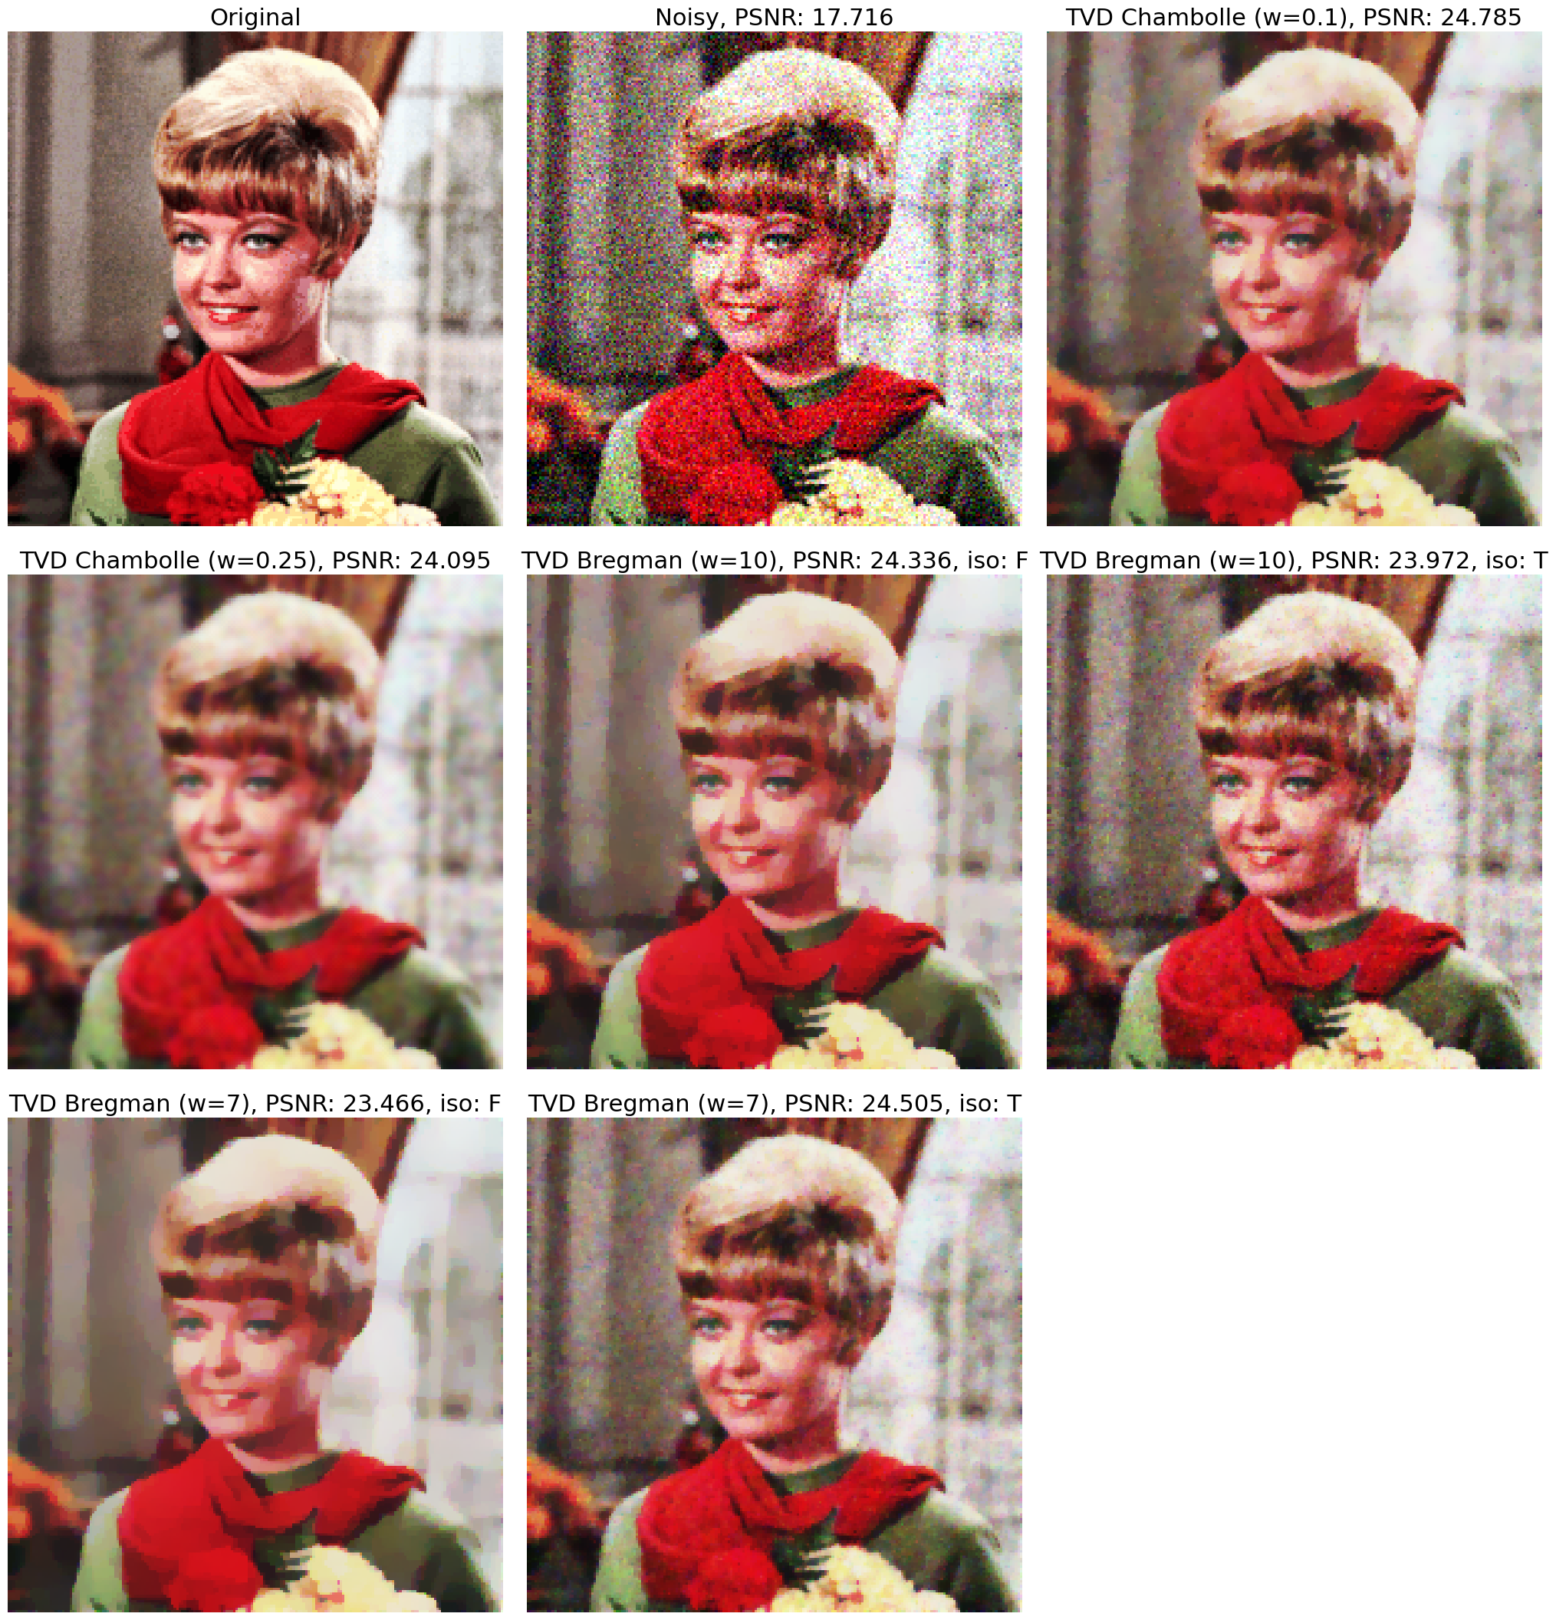

**Figure 1.22**:TV-denoising of the noisy Zelda image (with scikit-image’s Chambolle vs. Bregman method)

Image denoising with wavelets

Wavelets are a more general way to represent and analyze multiresolution images (recall we used a multi-resolution pyramid in part 1 of this book, where we could also reconstruct the image by just adding up all the residuals). A wavelet is a rapidly decaying wave-like oscillation that has zero mean and exists for finite durations. Wavelets come in different sizes and shapes; the following figure shows a few well-known families of wavelet basis functions (which need to be chosen carefully based on the application).

Wavelets [17] represent the scale of features in an image, as well as their position - they are a class of functions well-localized in time and frequency (hence, they can better represent, e.g., abrupt changes in images than Fourier transform). They are useful for a number of applications, including denoising, image compression, and image fusion.

We can use them to process images with the following steps:

1. Compute the 2D **discrete wavelet transform** (**DWT**).
2. Alter the transform.
3. Compute the **inverse** **discrete wavelet transform** (**IDWT**) for reconstruction.

There are a couple of important concepts in wavelets:

* **Scaling**: It refers to stretching/shrinking a signal in time, expressed using the equation $Ψ\left(\frac{t}{s}\right),s>0$.
* **Shifting**: It refers to delaying/advancing the onset of the wavelet along the length of the signal, expressed as $Φ\left(t-k\right)$.

Large-scale factors correspond to low frequency, and small-scale factors correspond to high frequency.

We do not need to calculate wavelet coefficients at every possible scale. We can choose scales based on powers of $2$, i.e., $2^{j}$ and translation as $2^{j}x$, with $j,x∈\{1,2,3,…\}$ and get equivalent accuracy:

$$Ψ_{j,k}\left(x\right)=2^{j/2}Ψ\left(2^{j}x-k\right)$$

We can represent a discrete function $f\left(n\right)$ as a weighted summation of wavelets $ψ\left(n\right)$, plus a coarse approximation $ϕ\left(n\right)$, as shown in the following figure [8]:

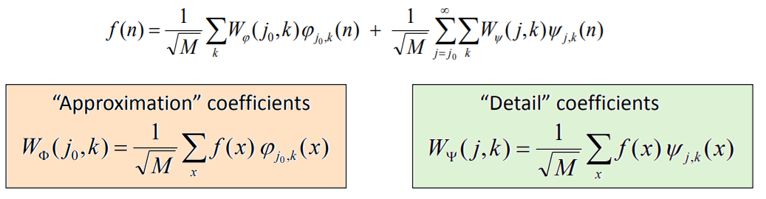

**Figure 1.23**:Approximation of a function by wavelets

Where $j_{0}$ is an arbitrary starting scale, and $n=0,1,2,…,M$. The above represents $x$ the DWT for a 1-D signal $x$, an image being a 2D signal, we need a 2D DWT instead.

The basic ingredient in DWT is multiresolution analysis. The main point is that the wavelet coefficients encode local information about the image in a way that makes it possible to discard all coefficients with absolute values below a given threshold and still be able to reconstruct the signal (image) with acceptable accuracy (allowing a sparse representation).

Again, an image, being a 2D function, can be represented by a sum of approximation plus details. The 2D DWT decomposes an image into approximation and details (e.g., horizontal, vertical, and diagonal details) at different scales/levels (using downsampling at Nyquist rate) recursively.

Similarly, IDWT reconstructs the images from the approximate and detailed coefficients at different scales (using upsampling), as shown in the following figure:

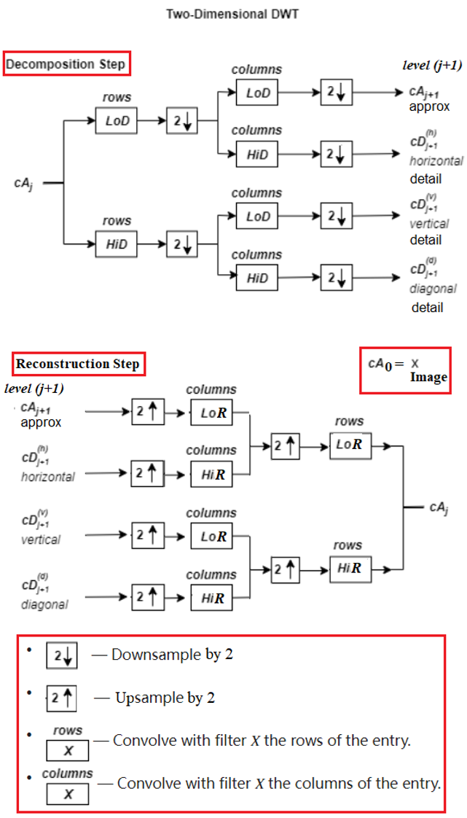

**Figure 1.24**: Image reconstruction with 2D discrete wavelet transform and its inverse

The following figure shows how the function wavedec2() from the Python package pywt works (at *level = n*):

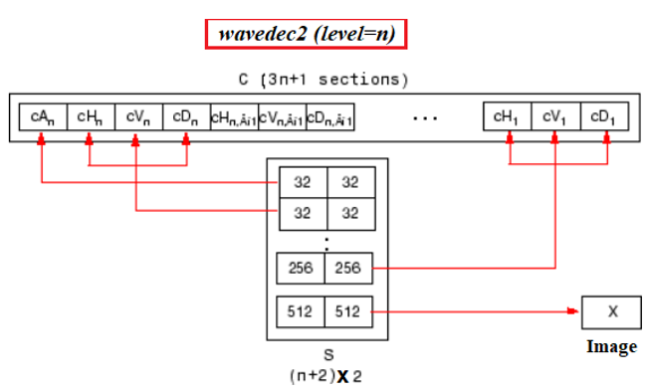

**Figure 1.24**: The function wavedec2() from the python package pywt

In this section, we will see how an image can be denoised/restored using wavelets (DWT), first using the DWT implementation from the library pywt and then using skimage.restoration corresponding implementation.

Wavelet-denoising with pywt

Thresholding is a nonlinear technique, yet it is very simple because it operates on one wavelet coefficient at a time. The key idea is to choose a threshold value (e.g., Donoho-Johnstone universal threshold) and zero out the wavelet coefficients obtained from multilevel DWT below the threshold, in order to remove noise from the degraded input image.

In this problem, you will understand how to use the functions from the library pywt to denoise an image using thresholding the wavelet coefficients of the image. Wavelet denoising has the following steps:

1. Perform a multilevel wavelet decomposition (use wavedecn() from pywt).
2. Identify a thresholding technique (soft/hard mode thresholding).
3. Threshold (using the threshold() function from pywt) and reconstruct (use waverecn() from pywt).

Let us start by importing the required libraries as usual:

import pywt  
#pywt.wavelist()

Read the grayscale input image of beans and degrade it by adding Gaussian noise with $σ=0.1$

noise_sigma = 0.1  
im = rgb2gray(imread('images/Img_01_16.jpg'))  
noisy = im + np.random.normal(0, noise_sigma, size=im.shape)

Let us perform multilevel wavelet decomposition using the function wavedecn(), which accepts the input image, the name of the wavelet family (db1) and number of levels ( $=2$ here) of decomposition. Let us plot the approximate and detailed coefficients at different scales by using the function coeffs_to_array() to arrange the wavelet coefficients list obtained from wavedecn() into a single array, as follows:

levels = 2  
wavelet = 'db1'  
coeffs = pywt.wavedecn(im, wavelet=wavelet, level=levels)   
arr, _ = pywt.coeffs_to_array(coeffs)  
  
plt.figure(figsize=(20,20))  
plt.imshow(arr, cmap='gray')  
plt.title('Discrete Wavelet Transform Coefficient for db1 Wavelet for level 3', \  
 size=20)  
plt.show()

If you run the above code snippet, you should obtain a figure like the next one:

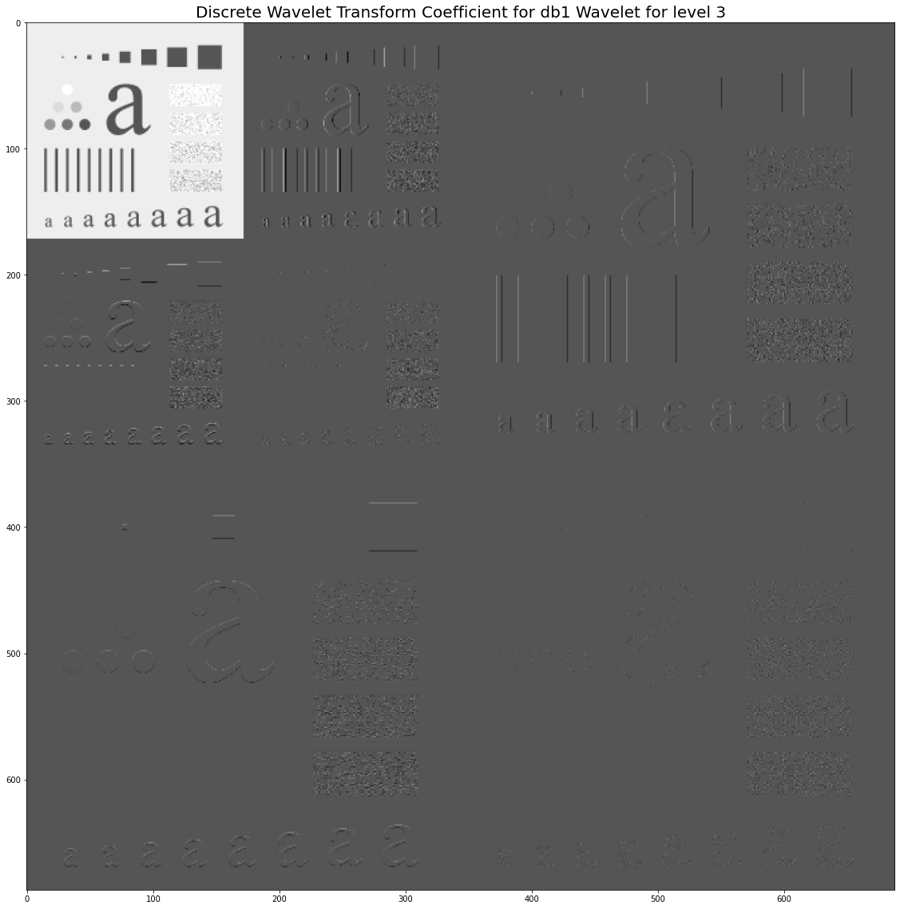

**Figure 1.25**:Multilevel wavelet decomposition with db1 wavelet family

Implement wavelet denoising with thresholding: define the denoise() function that accepts the degraded image, the name of the wavelet basis to be used, the noise standard deviation $σ$, and the mode of thresholding (hard or soft).

Threshold the detail (i.e., high frequency) coefficients using a Donoho-Johnstone universal threshold $t_{n}=σ\sqrt{2logn}$.

The following figure shows the difference between soft and hard thresholding:

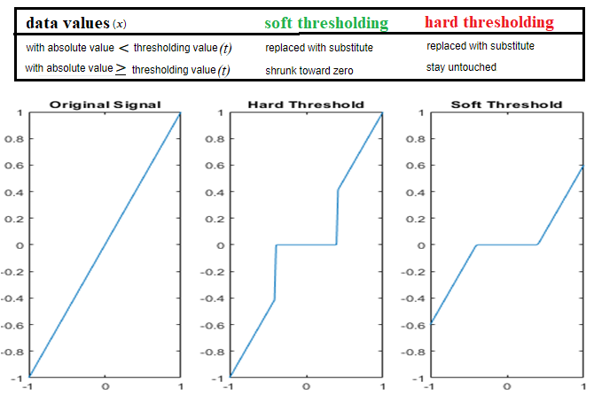

**Figure 1.26**:Soft vs. hard thresholding for a signal

In soft thresholding with threshold value ($t$), the data ($x$) is replaced by $sgn\left(x\right){\left(\left|x\right|-t\right)}_{+}$, i.e., data/np.abs(data) * np.maximum(np.abs(data) - value, 0) [18].

Invoke the function denoise() with appropriate arguments to obtain a smoothed image with different types of wavelets, starting from the grayscale beans image corrupted with random noise, as done in the following code snippet:

def denoise(img, wavelet, noise_sigma, mode='soft'):  
 levels = int(np.floor(np.log2(img.shape[0])))  
 coeffs = pywt.wavedecn(img, wavelet, level=3) #levels)   
 threshold = noise_sigma*np.sqrt(2*np.log2(img.size))  
 denoised_detail = [{key: pywt.threshold(level[key], value=threshold, mode=mode) \  
 for key in level} for level in coeffs[1:]]  
 denoised_root = pywt.threshold(coeffs[0], value=threshold, mode=mode)  
 denoised_coeffs = [denoised_root] + [d for d in denoised_detail]  
 out = pywt.waverecn(denoised_coeffs, wavelet)  
 return out  
  
im = rgb2gray(imread('images/Img_01_17.jpg'))  
noisy = im + np.random.normal(0, noise_sigma, size=im.shape)  
im_denoised_haar = denoise(noisy, wavelet='haar', noise_sigma=noise_sigma)  
im_denoised_haar_hard = denoise(noisy, wavelet='haar', noise_sigma=noise_sigma, \  
 mode='hard')  
im_denoised_db6 = denoise(noisy, wavelet='db6', noise_sigma=noise_sigma)

Plot the restored image using different wavelet families of basis functions (e.g., haar, db6, bior2.8, coif2) and different modes of thresholding (**hard** vs. **soft**), along with the original and the degraded images. You should obtain a figure like the following one:

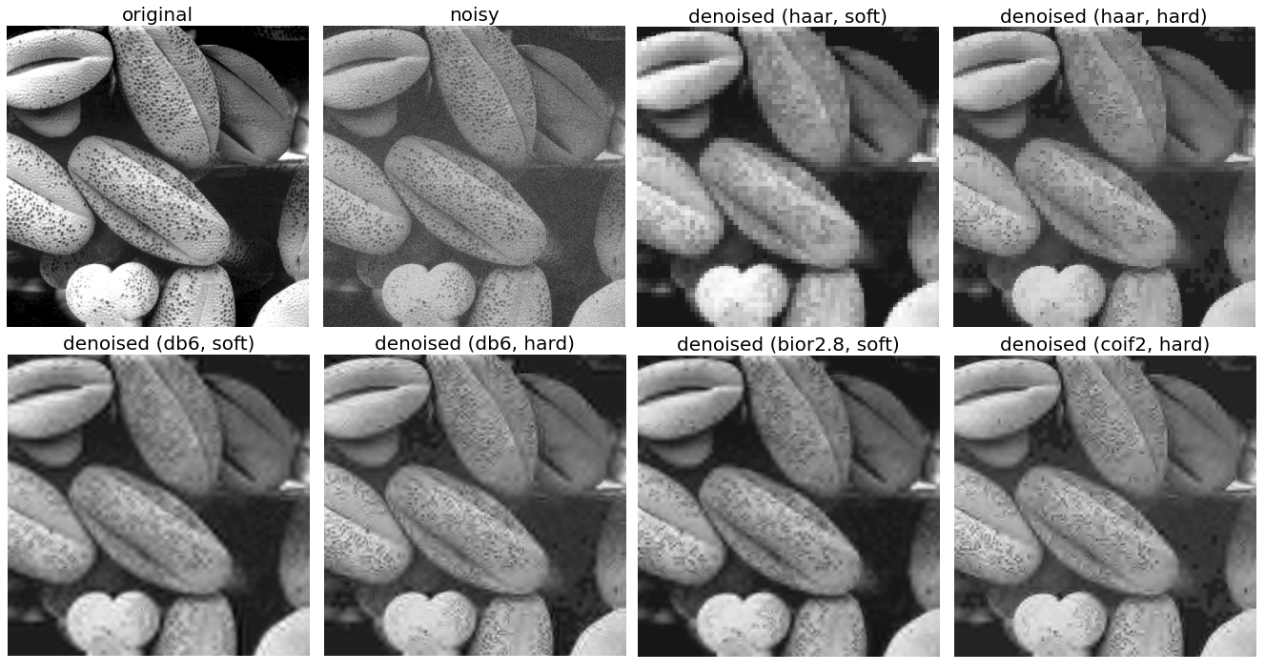

**Figure 1.27**:Image denoising using different wavelet families with hard vs. soft thresholding

Wavelet-denoising with scikit-image

In this problem, you will understand how to use wavelet-based denoising functions from skimage.restoration module. Similar to the frequency domain in DFT, the wavelet domain is yet another domain corresponding to a sparse representation of the image (with the majority of values zero and true random noise represented using many small values). For denoising, the usual approach is to set all values below a threshold (*t*) to $0$. If the threshold used is large, it can additionally remove the finer details in the image. In a multichannel (3D) input image, wavelet denoising is performed on each color plane separately.

Let us start by importing the required functions:

from skimage.restoration import (denoise_wavelet, estimate_sigma)

Read the color input image and degrade it with Gaussian noise, using the random_noise() function, as shown in the next code snippet (lines $1$- $3$).

Use the function estimate_sigma() from skimage.restoration module to estimate noise standard deviation for different color channels (line $4$).

The estimated standard deviation is expected to a bit smaller than the specified $σ$, due to clipping in random_noise().

Use the function denoise_wavelet() to apply the wavelet denoising on the degraded image. The following are the relevant arguments it accepts:

* image: Input image to be denoised.
* sigma: The noise standard deviation. It is used to compute detail coefficient thresholds.
* wavelet: The algorithm (type of wavelet) to be used, db1 being the default one.
* mode: Type of denoising, can be soft or hard. Soft thresholding finds the best approximation of the original image from the input noisy image, given the noise is additive.
* convert2ycbcr: Set to true to perform the wavelet denoising in YCbCr colorspace given multichannel (RGB color) input image, yielding better results often.
* **method**: Refers to the thresholding method to be used, which can be either of BayesShrink or VisuShrink.

The function denoise_wavelet() applies BayesShrink thresholding by default. Separate thresholds for each of wavelet sub-bands are computed in this adaptive thresholding method (lines $12$- $13$).

The VisuShrink thresholding, on the other hand, applies a single universal threshold to all of the wavelet detail coefficients. It removes all Gaussian noise with a given s.d. ($σ$) with high probability, but it is also prone to produce overly smooth images.

Use different scale factors (e.g., $2$, $3$, $4$) with estimated $σ$ (sigma_est) to decrease the threshold by these factors and observe the impact on the denoised image (lines $11$- $15$).

Compute PSNR as an indication of the output denoised image quality, given the input *noisy* image.

Plot the denoised images using different methods and thresholding modes, along with their psnr values as follows:

original = img_as_float(imread('images/Img_01_18.jpg'))  
sigma = 0.12  
noisy = random_noise(original, var=sigma**2)  
sigma_est = estimate_sigma(noisy, average_sigmas=True, channel_axis=-1)  
print(f'Estimated Gaussian noise standard deviation = {sigma_est}')  
# Estimated Gaussian noise standard deviation = 0.1208983266753569  
  
im_bayes = denoise_wavelet(noisy, convert2ycbcr=True, method='BayesShrink', \  
 mode='soft', rescale_sigma=True, channel_axis=-1)  
psnr_noisy, psnr_bayes = psnr(original, noisy), psnr(original, im_bayes)  
for sigma in [sigma_est/2, sigma_est/3, sigma_est/4]:  
 im_visushrink = denoise_wavelet(noisy, convert2ycbcr=True, method='VisuShrink', \  
 mode='soft', sigma=sigma, rescale_sigma=True, channel_axis=-1)  
 psnr_visushrink = psnr(original, im_visushrink)  
 # plot the output here  
 # your code here

You should obtain a figure as follows:

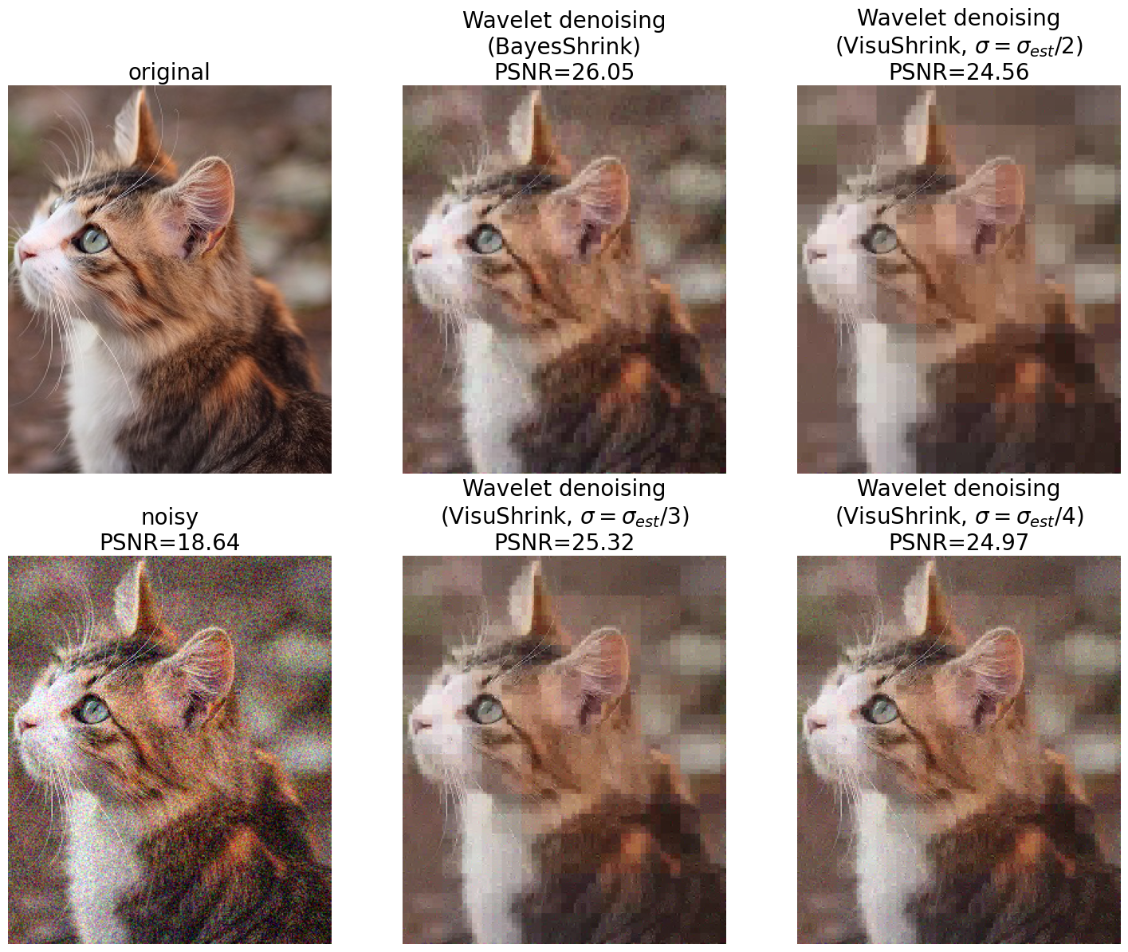

**Figure 1.28**:Wavelet denoising with BayesShrink vs. ViruShrink thresholding

scikit-image internally uses pywavelets for the implementation. The thresholding methods assume an orthogonal wavelet transform (e.g., Daubechies - db2, symmlet - sym2 families); they are desirable for the following reasons:

* They ensure the white noise in the input remains white noise in the subbands. (as opposed to the biorthogonal wavelets that produce colored noise in the subbands).
* In pywavelets*,* the orthogonal wavelets are also orthonormal*,* and hence, the noise variance in the subbands remains the same as that of input.

Denoising using non-local means with opencv-python

The principle of the first denoising method suggests replacing the color of a pixel with an average of the colors of nearby pixels. The variance law in probability theory ensures that if nine pixels are averaged, the noise standard deviation of the average is divided by three. The most similar pixels to a given pixel have no reason to be close to the pixel at all, non-local means method thus scans a vast portion of the image in search of all the pixels that really resemble the pixel to be denoised. Denoising is then done by computing the average color of these most resembling pixels, weighted the similarity of these pixels to the target pixel. It reduces the loss of detail (blurring) in the denoised image (when compared to its local counterpart), at the cost of more computation time.

Formally, a denoising method $D_{h}$ can be defined as a decomposition $v=D_{h}v+n\left(D_{h},v\right)$, where $v$ is the noisy image and $h$ is a filtering parameter which usually depends on the the noise variance $σ^{2}$. Ideally, $D_{h}v$ is smoother than $v$ and $n\left(D_{h},v\right)$ (i.e., the noise guessed by the method, defined as the method noise) should look like the realization of a white noise [20].

Given a noisy image $v=\{v\left(i\right)|i∈I\}$, the estimated value $NL\left[v\right]\left(i\right)$, for a pixel $i$, is computed as a weighted average of all the pixels in the image (or often in a larger search neighborhood),, where the family of weights $\{w\left(i,j\right)\}_{j}$ depend on the similarity between the pixels $i$ and $j$, and satisfy the usual conditions $0≤w\left(i,j\right)≤1$ and. The similarity between two pixels $i$ and $j$ depends on the similarity of the intensity gray level vectors $v\left(N_{i}\right)$ and $v\left(N_{j}\right)$, where $N_{k}$ denotes a square neighborhood (patch) of fixed size and centered at a pixel $k$.

The weights are given by $w\left(i,j\right)$, as shown in the following figure, where $Z\left(i,j\right)$ is a normalizing constant:

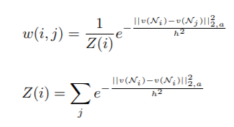

**Figure 1.29**:Normalizing the weights for pixels in the neighborhood

Again, to summarize, for each pixel, consider a small window (patch) containing it and search for similar patches in the image (in a search neighborhood), average all the patches found, and replace the pixel with the output. This is briefly what is done by the non-local means denoising method. If compared with other well-known denoising techniques, non-local means add method noise (i.e., error in the denoising process), which looks more like white noise, which is desirable because it is typically less disturbing in the denoised product.

In this problem, you will understand how to use opencv-python implementation of a non-local means filter to denoise an image.

We shall use the cv2.fastNlMeansDenoisingColored() function for denoising a color image. The function first converts the image from RGB colorspace to CIELAB (**Commission Internationale de l'Éclairage L*a*b**\*, where **L**\* represents lightness, and **a**\* and **b**\* represent color-opponent dimensions). It then denoises *L* and *AB* channels separately using the function cv2.fastNlMeansDenoising().

The function accepts the following arguments:

* src: In the input image, the *Zelda* RGB color image is used.
* templateWindowSize: The template patch size (in pixels) to be used used to compute weights.
* searchWindowSize: Size of the window to be used to compute the weighted average for a given pixel (the larger the window, the slower the filter).
* h: Controls filter strength for *L* (luminance) channel. Larger *h* removes noise along with image details.
* hColor: same as *h* for color components. For most images having $hColor=10$ is enough to remove colored noise without color distortion.

The function returns the denoised image.

Let us now proceed to use the aforementioned function to denoise a noisy color input image.

Let us first load the image of *Zelda* and degrade it with Gaussian noise, using cv2.randn().

img = cv2.imread('images/Img_01_02.jpg')  
noisy = img + cv2.randn(np.copy(img), (0,0,0),(10,10,10))

The following code snippet demonstrates the use of the function on a noisy color input image for different values of searchWindow (e.g., $\{15,21\}$) and h (e.g., $\{7,10,15\}$) parameters. Plot and compare the output denoised image’s quality with *PSNR* and time taken to denoise to obtain a figure like the following one:

for sz in [15, 21]:  
 for h in [7, 10, 15]:  
 start = time()  
 dst = cv2.fastNlMeansDenoisingColored(noisy, None, \  
 templateWindowSize=12, searchWindowSize=sz, h=h, hColor=10)  
 end = time()  
 # plot the denoised output image   
 # your code here

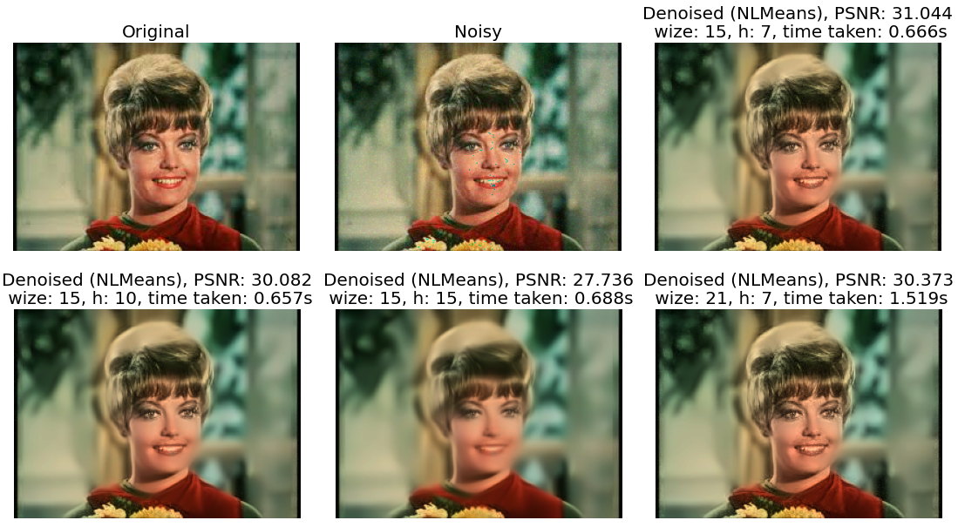

**Figure 1.30**:Denoising the Zelda color image with non-local means algorithm (opencv-python’s implementation)

Denoising with bilateral filter

A bilateral filter is a non-linear filter that can be used to denote/smooth an image by preserving the edges in the image. Like the other spatial filters (e.g., the average filter), each pixel is replaced by a (weighted) average of its neighbors (where weights can come from a Gaussian distribution). Unlike the other spatial filters, the weights depend not only on Euclidean distance of pixels but also on the radiometric differences (e.g., color, depth distance, etc.), enabling it to preserve the sharp edges [19]. Thus, it depends only on two parameters (a range and a spatial one) that indicate the size and contrast of the features to preserve.

The bilateral filter is defined as shown in the following figure, here $W_{p}$ is a normalization term. The weight $W_{p}$ is assigned using both the spatial proximity (measured by the spatial kernel $g_{s}\left(.\right)$ and the difference in intensity values (measured with the range kernel $f_{r}\left(.\right)$).

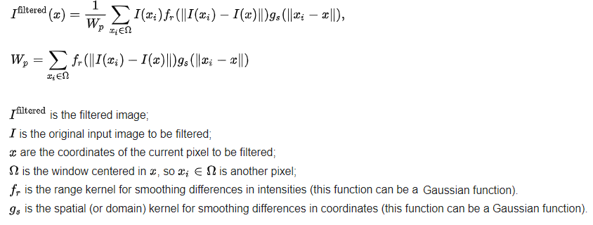

**Figure 1.31**:Filtering an image with bilateral filter

Consider a pixel at $\left(i,j\right)$ in the input image is to be smoothed/denoised with the pixels at its neighborhood. If one of the neighboring pixels is at $\left(k,l\right)$, then using Gaussian range and spatial kernels, the weight contribution computed for nbd pixel $\left(k,l\right)$ to denoise the pixel at $\left(i,j\right)$ is given by:

$$w\left(i,j,k,l\right)=exp\left(-\frac{{\left(i-k\right)}^{2}+{\left(j-l\right)}^{2}}{2σ_{d}^{2}}-\frac{∥I\left(i,j\right)-I\left(k,l\right)∥^{2}}{2σ_{r}^{2}}\right),$$

Where $σ_{d}$, $σ_{r}$ are the smoothing parameters (called the spatial and the range parameter, respectively), and $I\left(i,j\right)$, $I\left(k,l\right)$ represent pixel intensities at $\left(i,j\right)$ and $\left(k,l\right)$, respectively.

After calculating the weights, normalize them: where $I_{D}$ is the denoised intensity of pixel $\left(i,j\right)$.

As $σ_{r}$ increases, the bilateral filter reduces to Gaussian convolution.

As $σ_{d}$ increases, the larger features get smoothened.

In this section, you will understand how to use the bilateral filter implementations from the libraries SimpleITK and opencv-python to denoise an image.

Using SimpleITK

SimpleITK library’s BilateralImageFilter() uses bilateral filtering to blur an image using both domain and range neighborhoods. As described above, the pixels that are close to a pixel in the image domain and similar to a pixel in the image range are used to calculate the filtered value. Two Gaussian kernels (one in the image domain and one in the image range) are used to smooth the image.

The result is an image that is smoothed in homogeneous regions yet has edges preserved. The result is similar to anisotropic diffusion (refer to the one discussed in *Part 1* of this book), but the implementation is non-iterative. Another benefit to bilateral filtering is that any distance metric can be used for kernel smoothing the image range. Hence, color images can be smoothed as vector images, using the CIE distances between intensity values as the similarity metric (the Gaussian kernel for the image domain is evaluated using CIE distances).

Let us start by importing the required libraries, as usual.

Read the input Zelda image as a grayscale image, instantiate the ShotNoiseFilter object to alter the image with shot noise. The shot noise follows a Poisson distribution (*line $9$* ).

Instantiate an object of the BilaterImageFilter class (*line $11$* ).

Use the methods SetDomainSigma() and SetRangeSigma(), to set $σ_{d}$ and $σ_{r}$ parameters, respectively. DomainSigma is specified in the same units as the Image spacing. RangeSigma is specified in the units of intensity (*lines $20-21$* ).

Use the member function Execute() to apply the filter on the noisy input image, to have the denoised output returned.

Use a few different values of $σ_{d}$ and $σ_{r}$, to observe the impact of these parameters on the denoised output.

Plot the images using the code snippet shown as follows:

import SimpleITK as sitk  
  
def show_image(img, title=None):  
 nda = sitk.GetArrayViewFromImage(img)  
 plt.imshow(nda, cmap='gray'), plt.axis('off')  
 if(title): plt.title(title, size=20)  
  
img = sitk.ReadImage('images/Img_01_02.jpg', sitk.sitkUInt8)  
sf = sitk.ShotNoiseImageFilter()  
noisy = sf.Execute(img)  
f = sitk.BilateralImageFilter()  
  
plt.figure(figsize=(20,17))  
plt.subplot(331), show_image(img, 'original')  
plt.subplot(332), show_image(noisy, 'noisy')  
  
i = 3  
for σ_d in [5, 10]:  
 for σ_r in [25, 50, 75]:  
 f.SetDomainSigma(σ_d)  
 f.SetRangeSigma(σ_r)  
 denoised = f.Execute(noisy)  
 plt.subplot(3,3,i), show_image(denoised, 'denoised (σ_d={}, σ_r={})' \  
 .format(σ_d, σ_r))  
 i += 1  
  
plt.tight_layout()  
plt.show()

If you run the above code snippet, you should obtain a figure as follows:

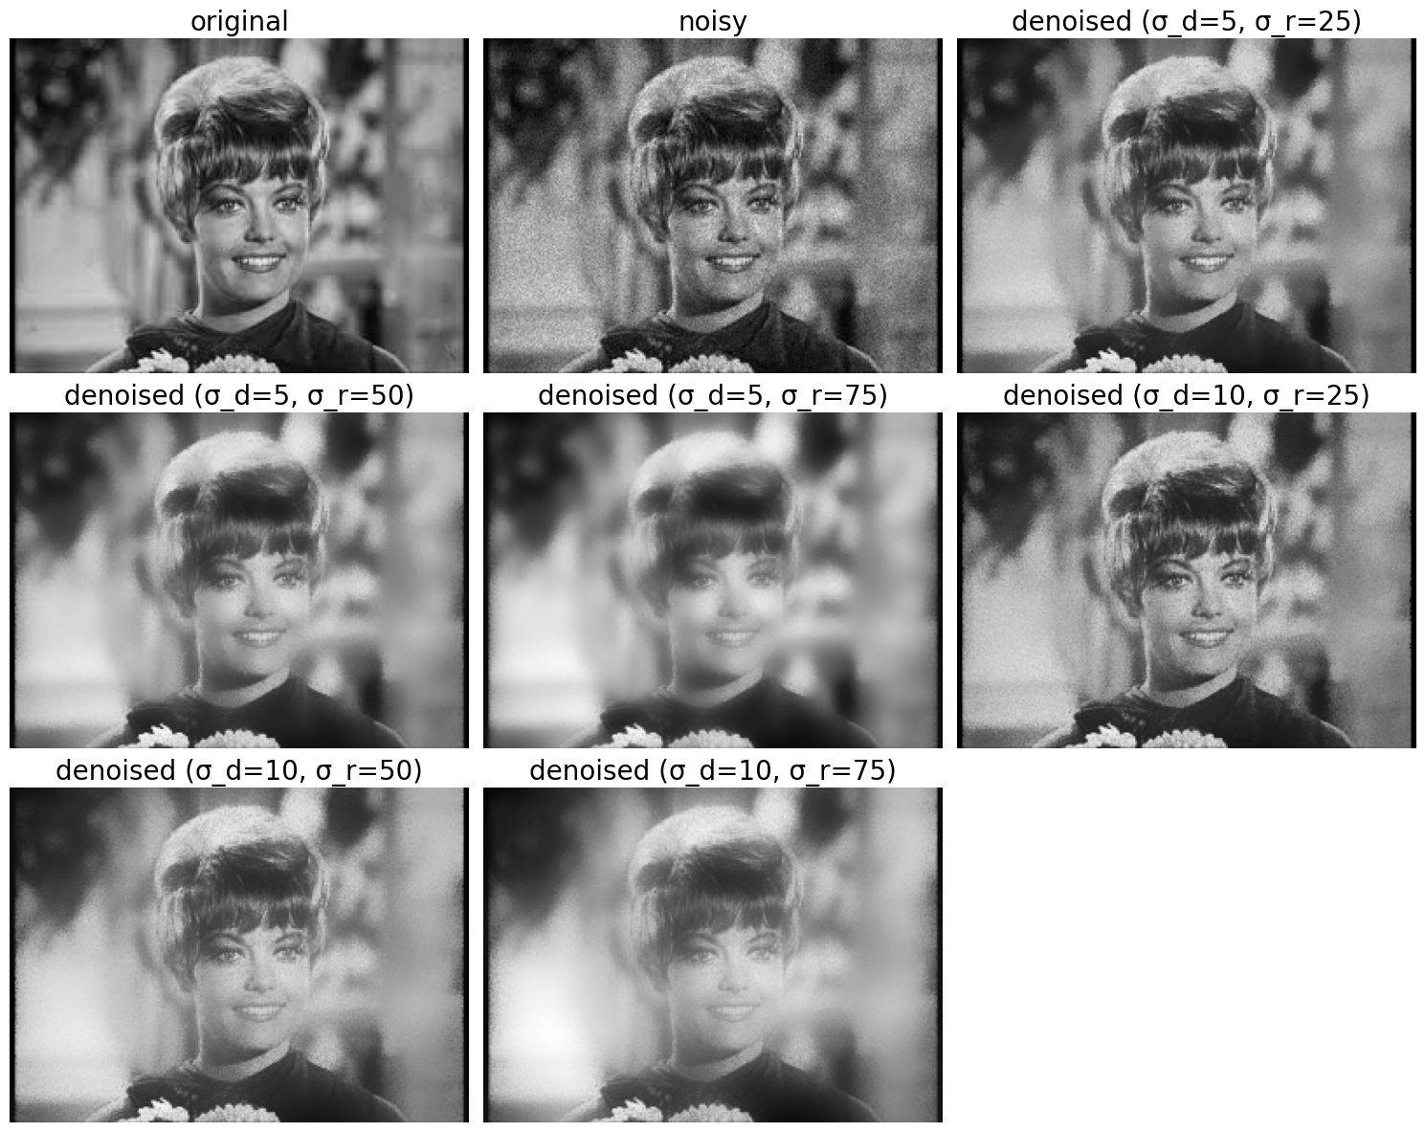

**Figure 1.32**:Denoising the grayscale Zelda image with bilateral filter (SimpleITK’s implementation)

Using opencv-python

As explained above, bilateral filtering operates both in the range and the domain of an image, unlike a traditional filter that operates only on the domain. Two pixels in an image can be close because of their spatial proximity or similarity in pixel values (i.e., in some perceptually meaningful manner), which is why bilateral filtering combines filtering in both the domain and range space.

In this section, you will understand how to use opencv-python implementation of a bilateral filter to smooth unnecessary noise from a degraded image and preserve the edges simultaneously. However, bilateral filters are computationally expensive and can be slow.

Let us start by reading the color image and adding Gaussian noise to the image using the cv2.randn() function.

Apply the bilateral filter using the function cv2.bilateralFilter() that accepts the following parameters:

* **src**: the noisy input image (can be grayscale or color). Here, we shall use the RGB color image of *Zelda* and degrade the image by adding random Gaussian noise with the function cv2.randn(), with s.d. $=10$ for each color channel.
* **d**: diameter of pixel nbd (or the filter size). Large filters ($d>5$) are very slow, let us use $d=5$ for real-time applications.
* **sigmaColor**: $σ_{c}$, s.d. of the Gaussian in color space (larger value implies mixing of farther colors in the *nbd*, resulting in larger areas of semi-equal color).
* **sigmaSpace**: $σ_{s}$ s.d. of the Gaussian in coordinate space (larger value indicates farther pixels influencing each other provided their colors are close).

For simplicity, both the sigma parameters can be set to the same value. Small (e.g., $<10$) values will not have much effect, whereas large (e.g., $>150$) will have a strong effect (the output image will be cartoonish).

Use a few different values for the parameters d (e.g., $\{9,15\}$), sigmaColor, and sigmaSpace (e.g., both in $\{75,180\}$) to observe the impact on these parameters on bilateral denoising and plot the output images.

img = cv2.imread('images/Img_01_02.jpg')  
noisy = img + cv2.randn(np.copy(img), (0,0,0), (10,10,10))  
  
for d in [9, 15]:  
 for σ_c in [75, 180]:  
 for σ_s in [75, 180]:  
 dst = cv2.bilateralFilter(noisy,d=d,sigmaColor=σ_c,sigmaSpace=σ_s)  
 # plot the output here  
 # your code…

If you plot the output images obtained using bilateral filtering with different combination of parameter values, as done in the above code snippet, you should obtain a figure like the next one:

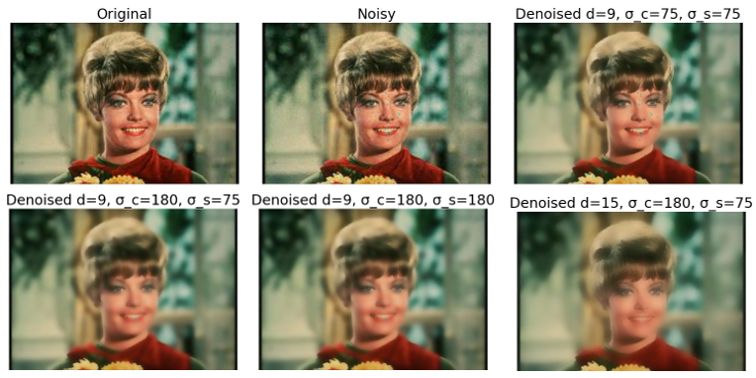

**Figure 1.33**:Denoising the Zelda color image with bilateral filter (opencv-python’s implementation)

Denoising with MAP Bayesian with an MRF prior

In Bayesian image denoising the optimal noiseless image is defined as the image that maximizes the posterior pdf. In this problem we shall implement a **maximum a-posteriori** (**MAP**) Bayesiandenoising algorithm that uses a noise model coupled with MRF prior that uses a $4$-neighborhood system (hence satisfies the Markov property, since a pixel is dependent only on its immediate neighbors).

The following figure explains the theory required to implement the denoising algorithm [22]:

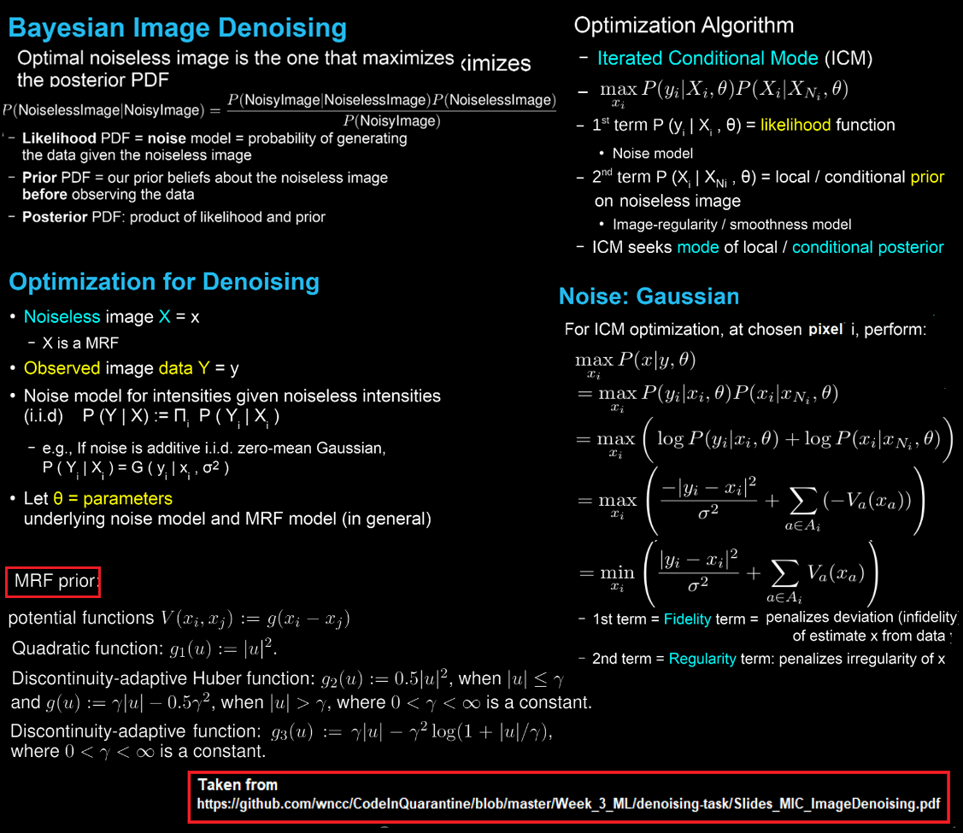

**Figure 1.34**:Denoising with MAP Bayesian and MRF prior

Let us start by importing the required libraries as follows:

from scipy.optimize import minimize

The following code snippet uses the quadratic MRF prior $g\left(u\right)={\left|u\right|}^{2}$ (try the other ones aforementioned).

For the chosen $g\left(.\right)$ function, minimize the following objective function (using the minimize() function from the scipy.optimize module) to get the denoised image:

$$∑α{\left(y_{i}-x_{i}\right)}^{2}+g\left(x_{i}-x_{i1}\right)+g\left(x_{i}-x_{i2}\right)+g\left(x_{i}-x_{i3}\right)+g\left(x_{i}-x_{i4}\right)$$

Where $i1$, $i2$, $i3$, $i4$ are the 4 neighbouring pixels of $i$, $y$ is the noisy image and $x$ is the denoised image. define the objective function in comp_obj_fun(), which accepts the input noisy image $Y$ and the output image $X$, along with the weight $α$.

The role of $g\left(.\right)$ is of edge preservation (neighbouring values of pixels should not differ by much, and should differ by much only at edges), the role of ${\left(y_{i}-x_{i}\right)}^{2}$ is noise removal.

The constant $α$ is to give weights to noise removal and edge preservation (controls the weighting between the prior and the likelihood).

Implement the gradient function grad_g() for the prior chosen and define the function compute_grad() that uses the function grad_g() as follows:

def g(u):  
 return np.sum(u**2)  
  
def grad_g(u):  
 return 2*u  
  
def compute_grad(X,Y,alpha):  
 X, Y = X.reshape(im_size), Y.reshape(im_size)  
 X1, X2, X3, X4 = np.roll(X, -1, 0), np.roll(X, 1, 0), np.roll(X, -1, 1), \  
 np.roll(X, 1, 1)  
 grad = alpha*grad_g(X-Y) + grad_g((X-X1) + (X-X2) + (X-X3) + (X-X4))  
 return grad.ravel()  
  
def compute_obj_fun(X,Y,alpha):  
 X, Y = X.reshape(im_size), Y.reshape(im_size)  
 X1, X2, X3, X4 = np.roll(X, -1, 0), np.roll(X, 1, 0), np.roll(X, -1, 1), \  
 np.roll(X, 1, 1)  
 loss = alpha*g(X-Y) + g(X-X1) + g(X-X2) + g(X-X3) + g(X-X4)  
 return loss

Read the input grayscale image and add impulse (salt & pepper) noise to the image. Initialize the output image with zeros before starting the iterative optimization, as shown in the following figure:

original = cv2.imread('images/Img_01_08.png', 0)  
original = original / original.max()  
noisy = random_noise(original, mode='s&p')  
denoised = np.zeros_like(noisy)  
im_size, alpha = original.shape, 1.5

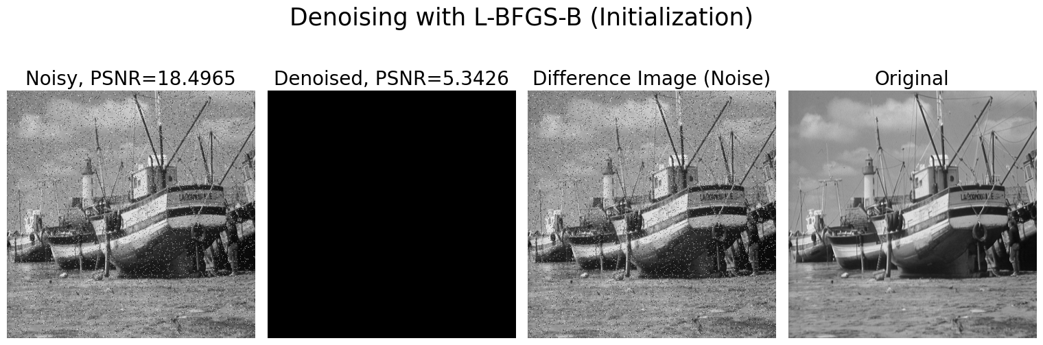

**Figure 1.35**: Denoising image with iterative LFBGS-B optimization algorithm (starting with zero image)

Use the minimize() function from scipy.optimize to minimize the objective function compute_obj_fun defined above, along with the gradient function compute_grad (as the *Jacobian*). The minimize function takes the following arguments, a few of the relevant ones are listed as follows:

* func: Objective function we want to minimize.
* x_0: The initial guess to start with.
* jac: Function to compute gradient.
* args: Extra arguments to be passed to objective function and its derivative.
* method: Solver to be used (e.g., L-BFGS-B).

Here we have used the maximum iteration as $4$ for the iterative solver and tolerance as $0.1$.

res = minimize(func=compute_obj_fun, x0=denoised.ravel(), \  
 jac=compute_grad, method='L-BFGS-B', args=(noisy.ravel(), alpha), \  
 options={'maxiter':4, 'gtol':0.1, 'disp': True})  
# print(res)

Retrieve the solution obtained and reshape it back into the output image.

Plot the denoised output image along with the difference image and compute the PSNR. The final output should be one, as shown:

denoised = res.x.reshape(im_size)

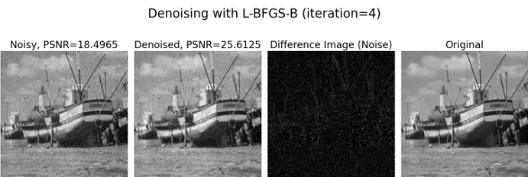

**Figure 1.36**: Denoising image with iterative LFBGS-B optimization algorithm (denoised image after 4 iterations)

Denoising images with Kernel PCA

**Kernel PCA** (**kPCA**) is an extension of **PCA**; a very popular linear dimension reduction technique. kPCA uses kernels to achieve non-linearity in dimensionality reduction.

In kPCA we choose a $Φ$ function which can be used to (conceptually) map to a very high-dimensional feature space, without the need for the data to be actually evaluated in that space. It’s done by computing the kernel $K=k\left(x,y\right)=\left(Φ\left(x\right),Φ\left(y\right)\right)=Φ{\left(x\right)}^{T}Φ\left(y\right)$, representing the inner product space of the otherwise intractable feature space [21]. Using the dual form*,* the kPCA never actually computes the eigenvectors (the principal components) and eigenvalues of the covariance matrix in the $Φ\left(x\right)$-space. Instead, it uses the kernel trick to compute the projections of the data onto the principal components, as shown in the following figure:

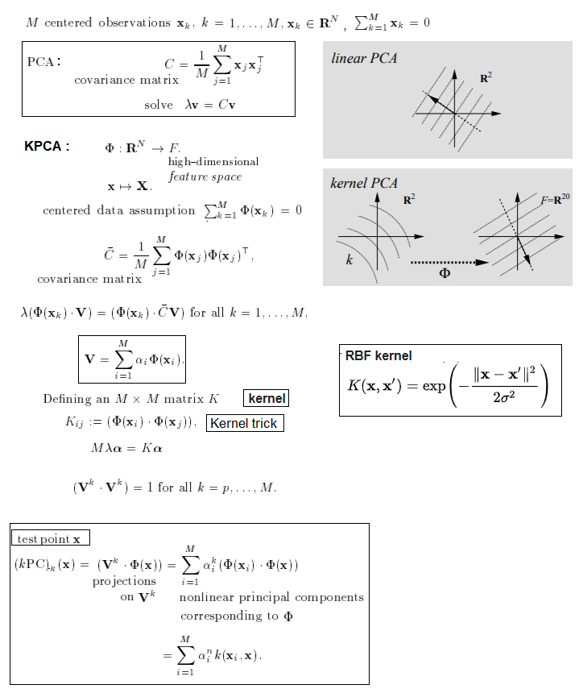

**Figure 1.37**:Image denoising with kPCA

While in PCA the number of components is bounded by the number of features, in kPCA the number of components is bounded by the number of samples (since it works in the dual space). Many real-world datasets have large numbers of samples, and hence, often, finding all the components with a full kPCA is a waste of computation time, as data is mostly described by the first few components (e.g., n_components $≤100$).

In this problem, you will learn how to use sci-kit-learn’s decomposition module’s KernelPCA implementation to denoise degraded MNIST images (of handwritten digits). The idea will be to learn a PCA basis (with and without a kernel) on noisy images and then use these models to reconstruct and denoise these images.

Let us start by importing the required libraries and modules using the following code snippet:

import pandas as pd  
from sklearn.preprocessing import MinMaxScaler  
from sklearn.model_selection import train_test_split  
from sklearn.decomposition import PCA, KernelPCA

Download the mnist train data from **Kaggle**: <https://www.kaggle.com/oddrationale/mnist-in-csv> as a .csv file, where there are 60k rows, with each *row* having $785$ columns: the last $784$ columns correspond to the pixel values of a $28×28$ handwritten digit image and the first column represents the label (class) of the digit ($0$- $9$).

Read the .csv file using pandas and display the first few rows as follows:

df = pd.read_csv('images/mnist_train.csv')  
df.head()

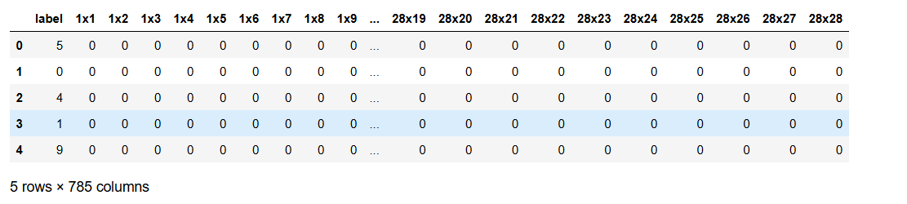

**Figure 1.38**:MNIST digits – Pandas DataFrame with 784 columns (each row represents a 28 x 28 digit)

Convert the images data to a Numpy array and scale the pixel values in between $0$- $1$ using the MinMaxScaler() from sklearn.preprocessning.

y = np.array(df.label.tolist())  
X = df.drop(columns=['label']).values  
X = MinMaxScaler().fit_transform(X)  
X.shape, y.shape  
*# ((60000, 784), (60000,))*

Use the function train_test_split() from sklearn.model_selection to create a training and a test dataset, with 1000 and 100 randomly selected images, respectively. These images are noise-free, and we will use them to evaluate the efficiency of the denoising approaches.

In addition, we create a copy of the original dataset and add Gaussian noise to the training, and we test images separately.

X_train, X_test, y_train, y_test = train_test_split(X, y, stratify=y, \  
 random_state=0, train_size=1_000, test_size=100)  
rng = np.random.RandomState(0)  
noise = rng.normal(scale=0.25, size=X_test.shape)  
X_test_noisy = X_test + noise  
noise = rng.normal(scale=0.25, size=X_train.shape)  
X_train_noisy = X_train + noise

The idea of this problem is to show that we can denoise corrupted images by learning a PCA basis on some uncorrupted images. We will compare denoising performed by PCA and kPCA.

Instantiate objects of PCA and KernelPCA classes from sklearn.decomposition module to fit PCA and kPCA models on the training images, respectively.

The KernelPCA constructor accepts the following arguments, a few relevant ones are listed as follows:

* n_components: Number of components (we have chosen first $30$ PCs for PCA and first $400$ PCs for kPCA out of $784$ possible components).
* kernel: Kernel used for kPCA (we have chosen the **Radial Basis Function** (rbf) kernel), defined as $k\left(x,y\right)=e^{-γ∥x-y∥^{2}}$.
* gamma: Kernel coefficient $γ$ for the rbf kernel.
* alpha: Hyperparameter of the ridge-regression that learns the inverse-transform (when fit_inverse_transform=True).
* fit_inverse_transform: Learn the inverse transform (used for reconstruction).

As can be seen from the aforementioned, KernelPCA supports both transform() and inverse_transform()

Let us understand the basis vectors using both a linear PCA and a kernel PCA that uses a rbf kernel.

Use the fit() methods to fit the models on training images for both models as follows:

pca = PCA(n_components=30)  
kernel_pca = KernelPCA(n_components=400, kernel="rbf", gamma=1e-3, \  
 fit_inverse_transform=True, alpha=5e-3)  
pca.fit(X_train_noisy)  
_ = kernel_pca.fit(X_train_noisy)  
pca.n_features_in_, kernel_pca.n_features_in_  
# (784, 784)

Now, let us project the noisy *test* images on the kernel space (with the function transform()) and then reconstruct (with inverse_transform()) the images. Since a number of components used is less than the number of original features, an approximation of the original test images will be obtained. By dropping the components that explain the least variance in PCA (same for kPCA), we hope to remove noise.

For kPCA, a better reconstruction should happen since a non-linear kernel is used to learn the basis, and a kernel ridge is used to learn the mapping function.

X_reconstructed_kernel_pca = kernel_pca.inverse_transform(kernel_pca.transform(X_test_noisy))  
X_reconstructed_pca = pca.inverse_transform(pca.transform(X_test_noisy))

Let us use the **mean squared error** (**MSE**) to quantitatively assess the image reconstruction (e.g., compute MSE for PCA with np.mean((X_test - X_reconstructed_pca) ** 2)).

Plot the original (uncorrupted) and the reconstructed test digit images (obtained with PCA and KPCA) along with the MSE value using the plot_digits() function. You should get a figure like the following one:

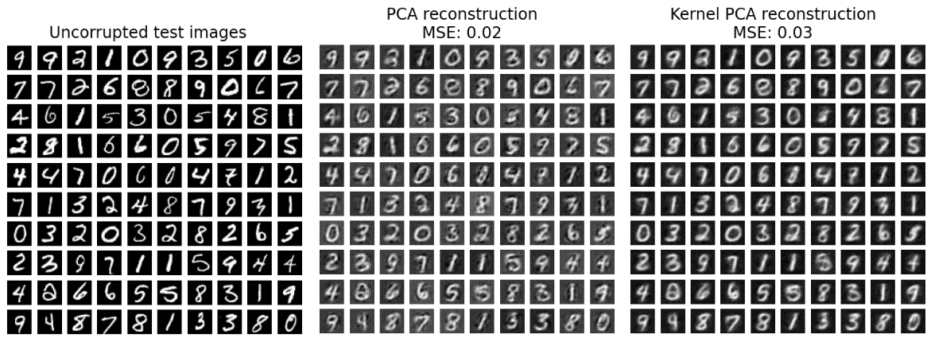

**Figure 1.38**:PCA vs. Kernel-PCA reconstructions of noisy MNIST digits

From the above output, although it can be seen that PCA has lower MSE than kPCA, observe that kPCA is able to remove background noise and provide a smoother image.

Also, the results of the denoising with kPCA will depend on the hyperparameters n_components, gamma, and alpha (tune them and note the change in MSE).

Conclusion

In this chapter, we focused on solving quite a few problems in image restoration and inverse problems in image processing. By now, you should be able to apply non-linear filters such as median and weighted median filters to denoise an image, apply non-blind deconvolutions to restore degraded images using Inverse, Wiener filters, blind / non-blind deconvolution with RL algorithm, TV denoising with Chambolle/Bregman algorithms, Wavelet denoising, nonlocal / bilateral filters for image restoration, Bayesian optimization and Kernel PCA for image denoising, using different Python libraries such as scikit-image, scipy.ndimage, SimpleITK, opencv-python, pywt, and matplotlib.

In the next chapter, we shall continue our discussion on solving more image restoration and image inpainting problems; we shall see how a few deep neural nets (such as AutoEncoders and GANs) can be applied to solve problems such as image deblurring and deraining.

Questions

1. Prove that the solution to the optimization (minimization) problem with the loss function

$$loss_{Ridge}={\left(g-Af\right)}^{T}\left(g-Af\right)+αf^{T}f$$

is given by the following normal equation:

$$f={\left(A^{T}A+αI\right)}^{-1}A^{T}g$$

1. Rather than using the normal equations to solve inverse problems, numerical analysis suggests that it is preferable to solve the augmented equations, as shown in the following figure, which can be done by a **least squares solver** (**lsqr**). Compare the performance to the one you used in problem 0 in terms of the number of iterations required to achieve convergence.

The sum of absolute deviations is minimum when it is taken from the median: Let us $S=\{X_{1},X_{2},…,X_{n}\}$ be a set of numbers s.t., $X_{1}≤X_{2}≤…≤X_{n}$. Prove that $\sum_{k=1}^{n}{\left|X_{k}-θ\right|}$ is minimum when $θ=median\left(S\right)$.

$$\left({A \atop \sqrt{α}.I}\right)f=\left({g \atop 0}\right)$$

1. Start with the noisy beans image; visualize how the DWT coefficients change when thresholder with different threshold values, along with the change in PSNR of the denoised image, with hard/soft thresholding, and find the thresholds corresponding to the peak PSNR values; you should get a figure that looks like the one shown:

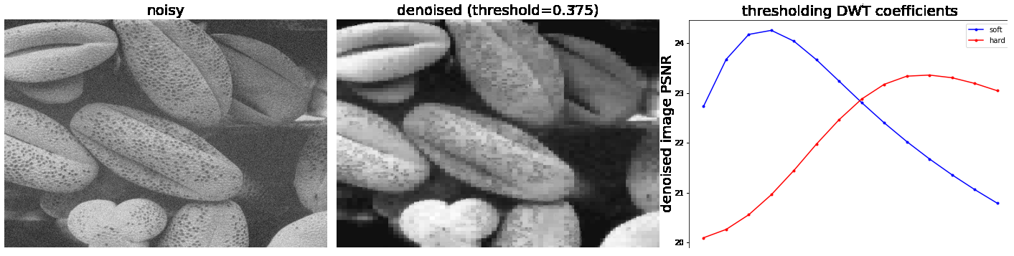

**Figure 1.39**:Denoising the beans grayscale image with DWT (hard vs. soft thresholding**)**

1. Use Savitzky–Golay filter (scipy.signal.savgol_filter) to denoise an image. Play with the window length and the polynomial-degree parameters to understand the impact on smoothing.
2. **Impact of noise on Inverse Filter**: Start with $G\left(u,v\right)=F\left(u,v\right)H\left(u,v\right)+N\left(u,v\right)$, where $N\left(u,v\right)$ is the frequency spectrum of the additive noise. Show that restoration with an inverse filter gets impacted badly as the additive noise gets stronger (demonstrate with an example). Can the Wiener filter resolve the problem?
3. Compare the restored image quality (e.g., with PSNR) obtained with the Wiener deconvolution implementations from scipy.signal and those obtained using the Wiener-Hunt deconvolution and its unsupervised version’s implementations from skimage.restoration.
4. Use denoise_nl_means() and denoise_bilateral() functions from skimage.restoration to apply non-local mean and bilateral denoising on a noisy image. Compare the results with those obtained using opencv-python.
5. Use the code for non-local means denoising implementation with opencv-python to visualize (in 3D) how the PSNR and the time taken to denoise varies with input parameters $h$, and $searchWindowSize$ you should obtain a figure as follows:

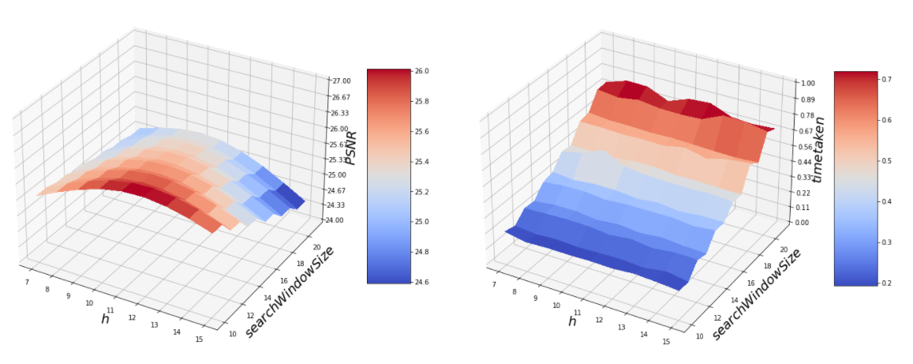

**Figure 1.40**: 3D plot of PSNR w.r.t. parameters h and searchWindowSize

Try changing the value of the other parameters too, in roddr to observe the impact on the denoised image quality and the computational efficiency.

1. **Anisotropic diffusion**: Refer to part 1 of this book (Chapter 5) to implement the classic Perona–Malik algorithm to restore a degraded image and compare the output obtained with the other restoration methods.
2. Deep Inverse problems in Python: implement deep image reconstruction with the Python package DeepInPy, as explained in the following research paper <https://www1.icsi.berkeley.edu/~stellayu/publication/doc/2020deepInPyISMRM.pdf>.

Key terms

TV denoising, Richardson-Lucy, Kernel PCA, Wiener, MAP Bayesian, Wavelet, Deconvolution, ROF, Chambolle, Bregman.

References

1. <https://math.stackexchange.com/questions/113270/the-median-minimizes-the-sum-of-absolute-deviations-the-ell-1-norm/4281480#4281480>
2. <https://www.owlnet.rice.edu/~elec539/Projects99/BACH/proj2/intro.html>
3. <https://www.youtube.com/watch?v=WYtKSZcX944>
4. <http://www0.cs.ucl.ac.uk/staff/S.Arridge/teaching/optimisation/>
5. <https://www.ipol.im/pub/art/2012/g-tvd/article_lr.pdf>
6. <https://mathworld.wolfram.com/Euler-LagrangeDifferentialEquation.html>
7. <https://sipi.usc.edu/database/database.php>
8. <http://leap.ee.iisc.ac.in/sriram/teaching/MLSP_16/refs/W24-Wavelets.pdf>
9. <https://courses.cs.duke.edu/cps258/fall06/references/Nonnegative-iteration/Richardson-alg.pdf>
10. <https://web.archive.org/web/20190110142859/https://pdfs.semanticscholar.org/9e3f/a71e22caf358dbe873e9649f08c205d0c0c0.pdf>
11. <https://www.amazon.com/Python-Image-Processing-Cookbook-processing-ebook/dp/B084ZN7Y5F/>
12. <https://www.amazon.com/Hands-Image-Processing-Python-interpretation-ebook/dp/B07J664F9S/>
13. <https://www.amazon.com/Image-Processing-Masterclass-Python-Techniques-ebook/dp/B08YK4CC7S/>
14. <https://www.scratchapixel.com/lessons/digital-imaging/simple-image-manipulations/bookeh-effect>
15. <https://arxiv.org/pdf/1004.5538.pdf>
16. <https://scikit-image.org/docs/dev/api/skimage.restoration.html>
17. <https://in.mathworks.com/videos/understanding-wavelets-part-1-what-are-wavelets-121279.html>
18. <https://web.stanford.edu/dept/statistics/cgi-bin/donoho/wp-content/uploads/2018/08/denoiserelease3.pdf>
19. [https://users.soe.ucsc.edu/~manduchi/Papers/ICCV 98.pdf](https://users.soe.ucsc.edu/~manduchi/Papers/ICCV%2098.pdf)
20. <http://www.iro.umontreal.ca/~mignotte/IFT6150/Articles/Buades-NonLocal.pdf>
21. <https://citeseerx.ist.psu.edu/viewdoc/download;jsessionid=C2973F67552E7DD1D2FB5D592DFE9ACB?doi=10.1.1.100.3636&rep=rep1&type=pdf>
22. <https://github.com/wncc/CodeInQuarantine/blob/master/Week_3_ML/denoising-task/task.pdf>